PRACTICAL JOURNAL

In

Machine Learning

**Submitted to**

**Laxman Devram Sonawane College , Kalyan (west) 421301**

*In partial fulfillment for the award of the degree of*

**Master of Science**

**IN**

**Information Technology**



(Affiliated to University of Mumbai)

*Submitted by*

**Prathamesh Pramod Rahate**

UNDER THE GUIDENCE OF

**Snehal Yeole**

DEPARTMENT OF INFORMATION TECHNOLOGY

Kalyan, Maharashtra

Academic Year 2022 – 2023

 The Kalyan Wholesale Merchants Education Society’s

**LAXMAN DEVRAM SONAWANE**

**DEGREE COLLEGE**

**Department of Information Technology**

**M.Sc. Part – II**

**Certificate**

This is to certify that,

Mr/Ms.**Prathamesh Pramod Rahate**, Seat No. **3270016** , Studying in Master of Science in Information Technology Part – II Semester – III has satisfactorily completed the practical of “**Machine Learning**” as prescribed by university of mumbai, during acedemic year 2022-2023.

------------------------- ------------------------- -------------------------

---------------------------

INDEX

|  |  |  |
| --- | --- | --- |
| **Sr.**  **No.** | **Practical** | **Pg. No.** |
| **1** | 1. **Design a simple machine learning model to train the training instances and test the same using Python.** 2. **Implement and demonstrate the FIND-S algorithm for finding the most specific hypothesis based on a given set of training data samples. Read the training data from a .CSV file.** | **1** |
| **2** | 1. **Perform Data Loading, Feature selection (Principal Component analysis) and Feature Scoring and Ranking.** 2. **For a given set of training data examples stored in**   **.CSV file, implement and demonstrate the Candidate- Elimination algorithm to output a description of the set of all hypotheses consistent with the training examples.** | **10** |
| **3** | **B. Write a program to implement Decision Tree and Random forest with Prediction, Test Score and Confusion Matrix.** | **21** |
| **4** | 1. **For a given set of training data examples stored in a .CSV file implement Least Square Regression algorithm. (Use Univariate dataset )** 2. **For a given set of training data examples stored in a .CSV file implement Logistic Regression algorithm. (Use Multivariate dataset )** | **25** |

|  |  |  |
| --- | --- | --- |
| **5** | 1. **Write a program to demonstrate the working of the decision tree based ID3 algorithm. Use an appropriate data set for building the decision tree and apply this knowledge to classify a new sample.** 2. **Write a program to implement k-Nearest Neighbour algorithm to classify the iris data set.** | **36** |
| **6** | 1. **Implement the different Distance methods (Euclidean, Manhattan Distance, Minkowski Distance) with Prediction, Test Score and Confusion Matrix.** 2. **Implement the classification model using clustering for the following techniques with K means clustering with Prediction, Test Score and Confusion Matrix.** | **44** |
| **7** | 1. **Implement the classification model using clustering for the following techniques with hierarchical clustering with Prediction, Test Score and Confusion Matrix** 2. **Implement the Rule based method and test the same.** | **53** |
| **8** | 1. **Write a program to construct a Bayesian network considering medical data. Use this model to demonstrate the diagnosis of heart patients using standard Heart Disease Data Set.** 2. **Implement the non-parametric Locally Weighted Regression algorithm in order to fit data points. Select appropriate data set for your experiment and draw**   **graphs.** | **60** |

PRATICAL NO 1

**AIM: A) Design a simple machine learning model to train the training instances and test the same using Python.**

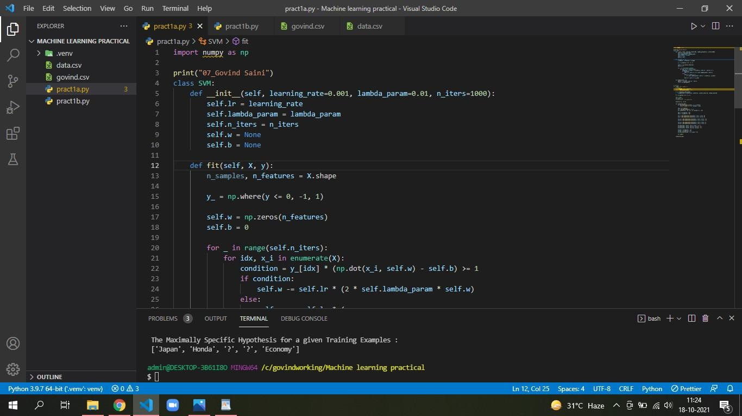**CODE:**

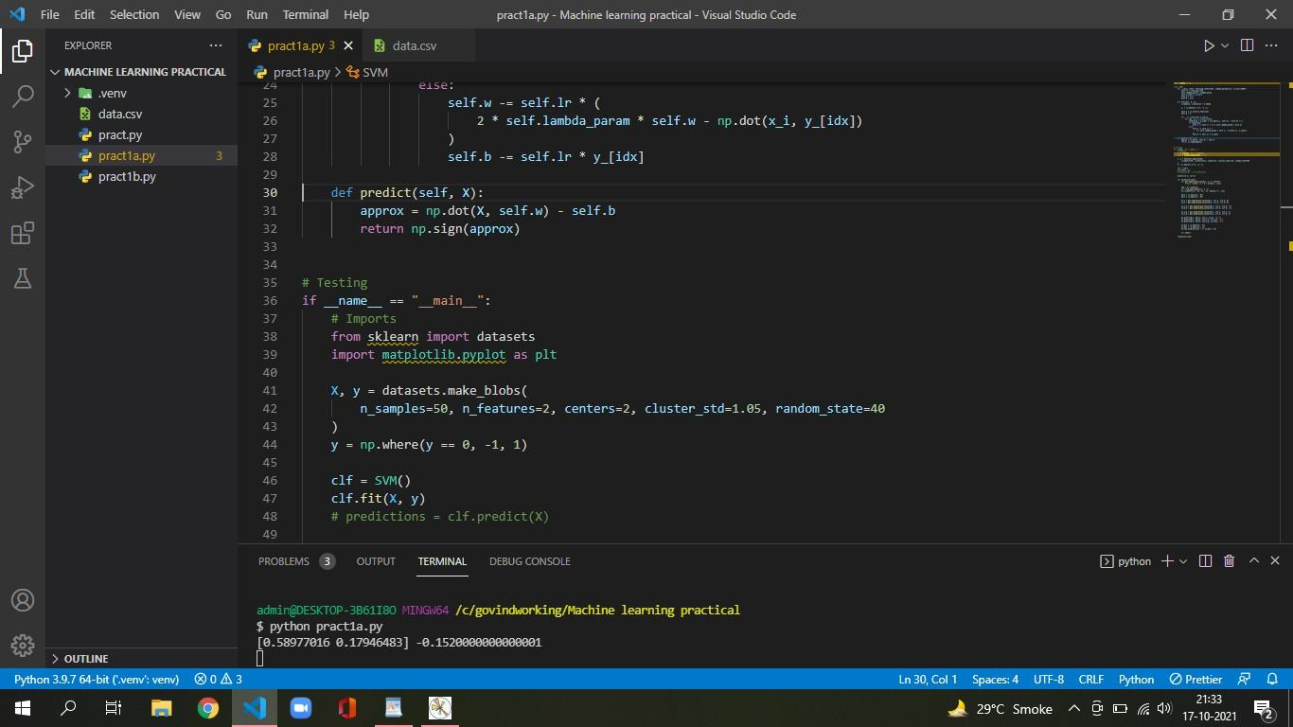

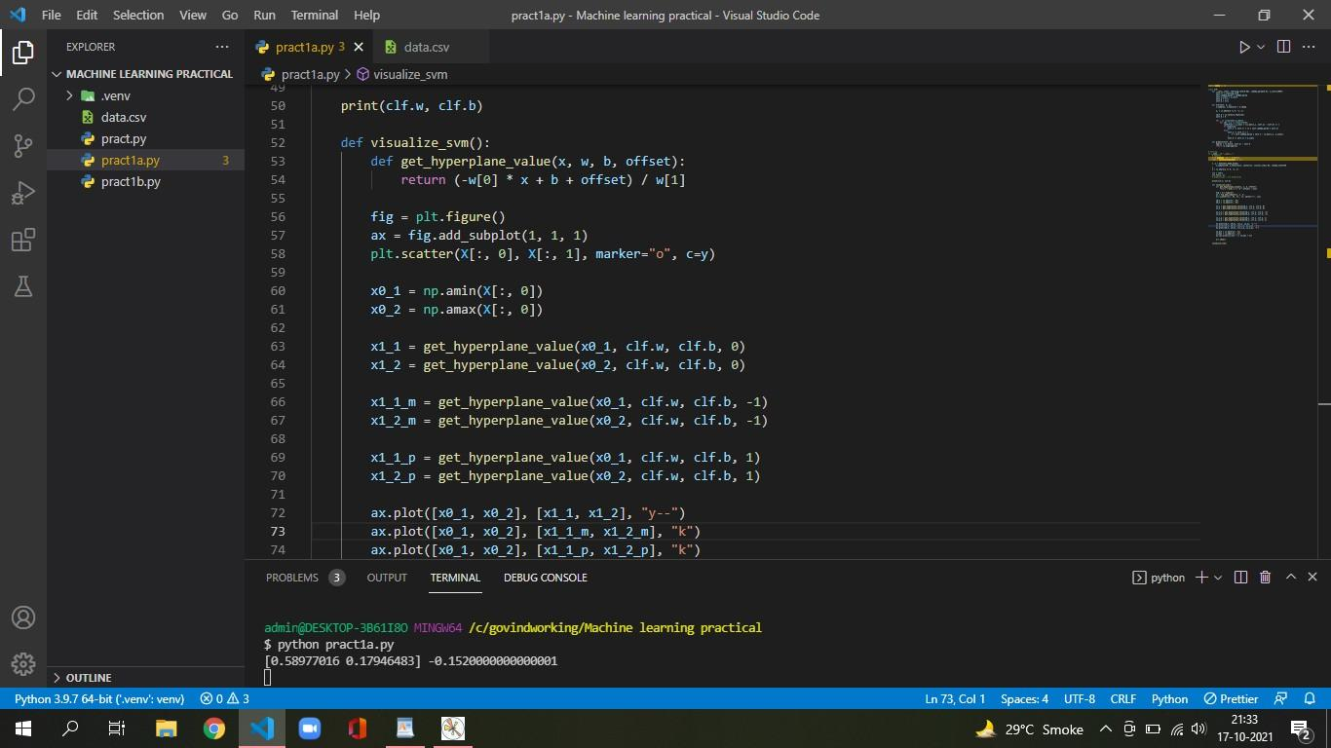

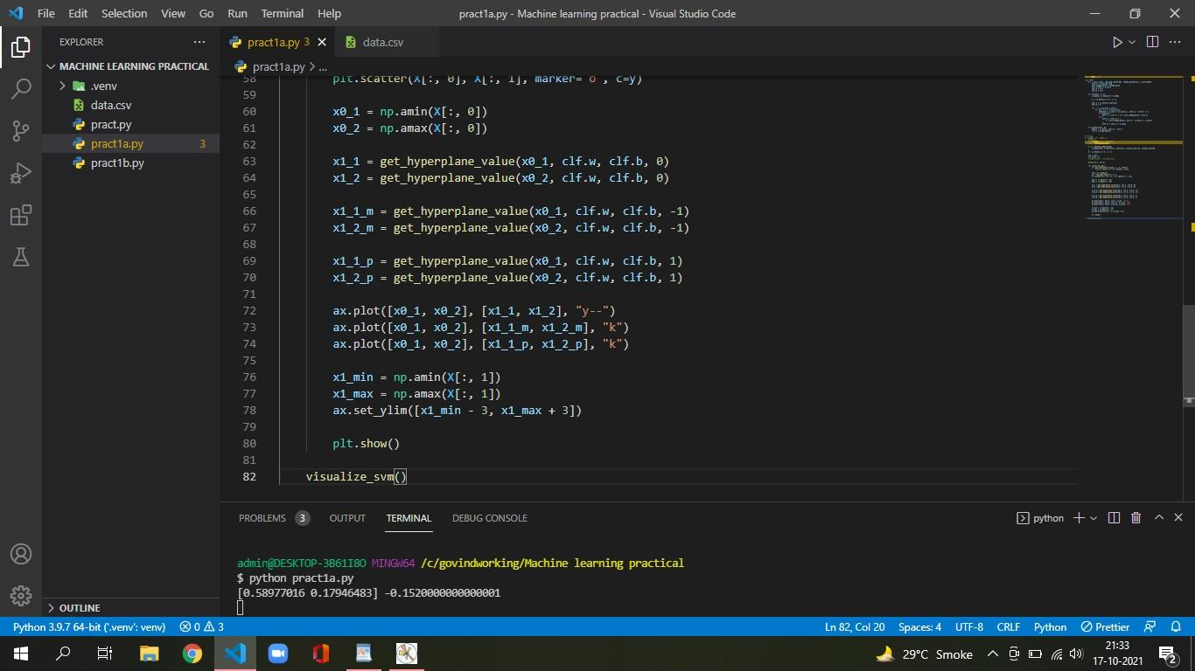

**Output :**

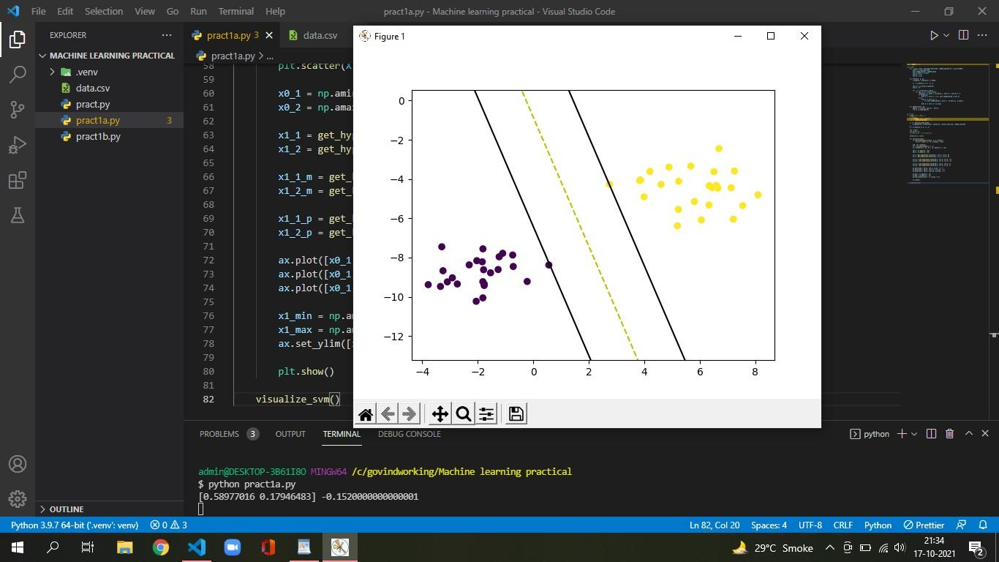

**B) Implement and demonstrate the FIND-S algorithm for finding the most specific hypothesis based on a given set of training data samples. Read the training data from a .CSV file**

**CODE:**

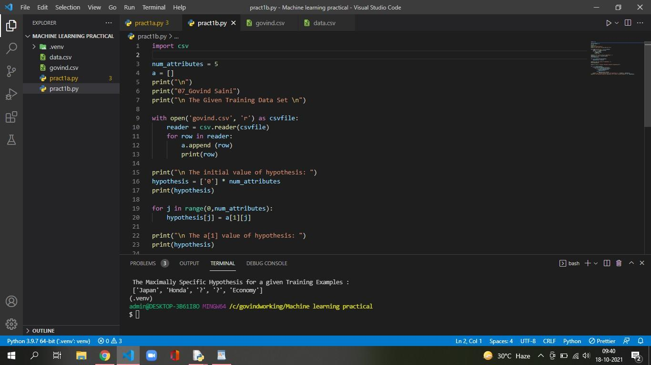

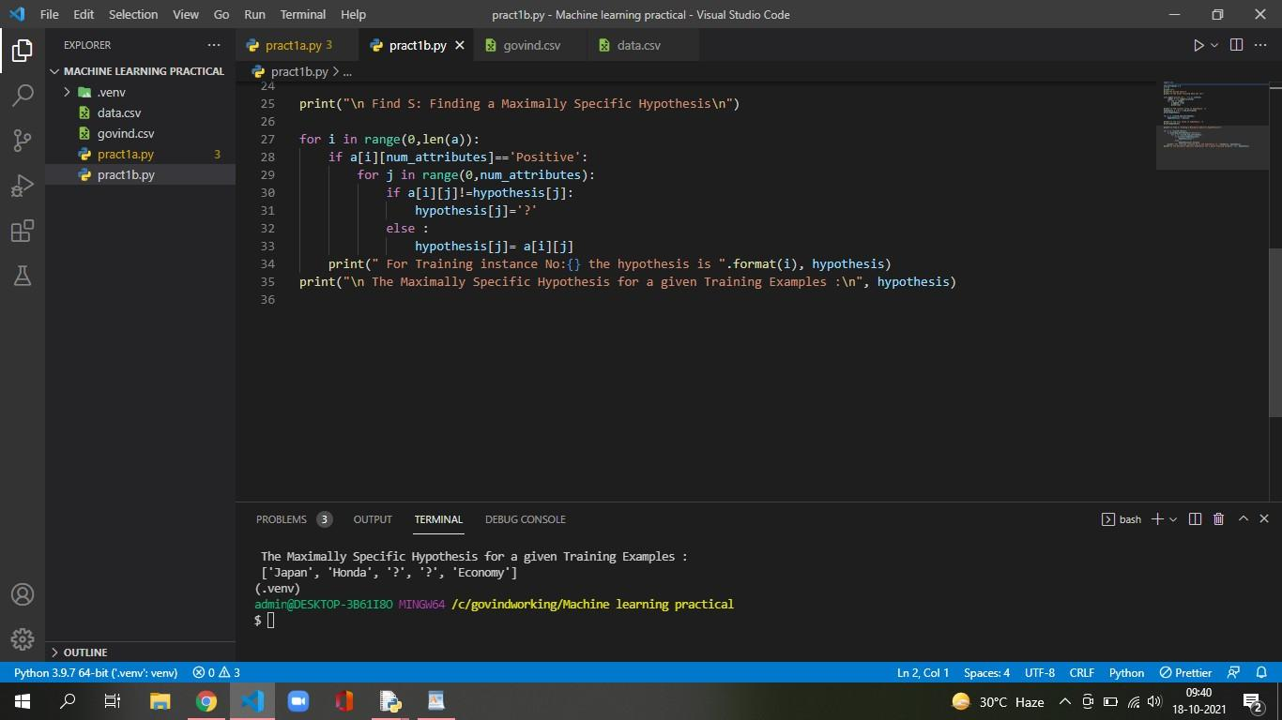

**OUTPUT:**

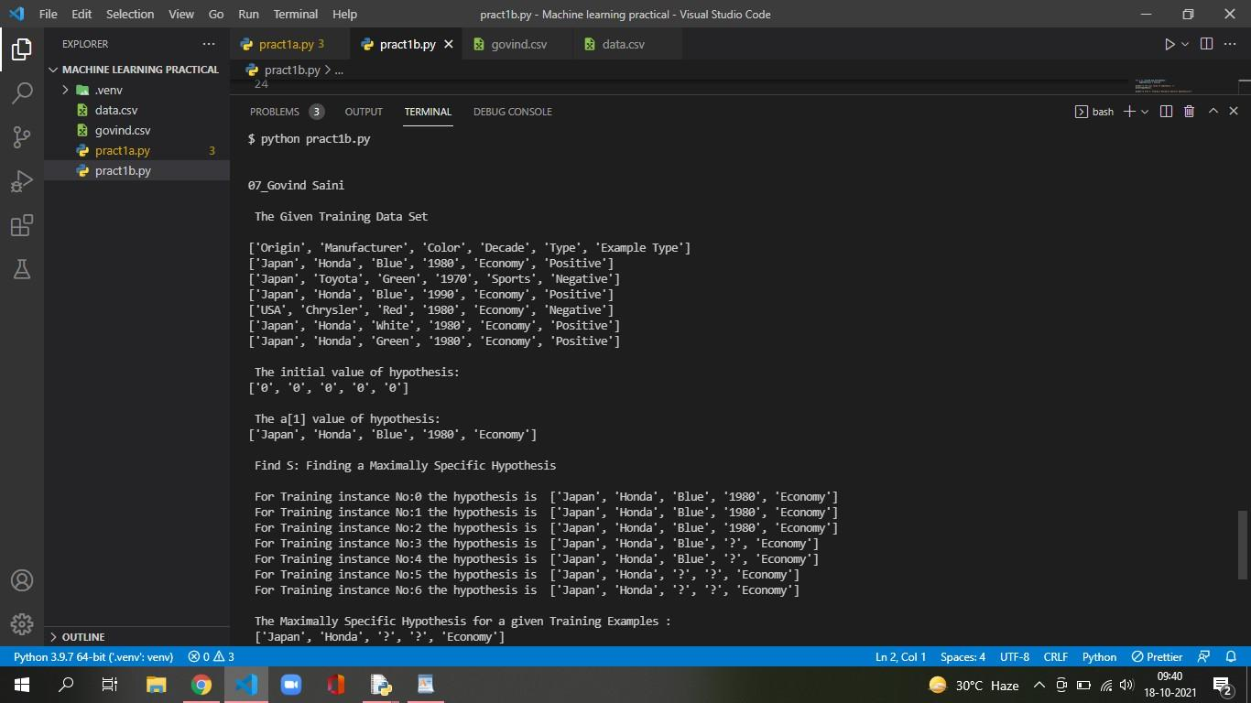

PRATICAL NO 2

**AIM: A) Perform Data Loading, Feature selection (Principal Component analysis) and Feature Scoring and Ranking.**

**CODE:**

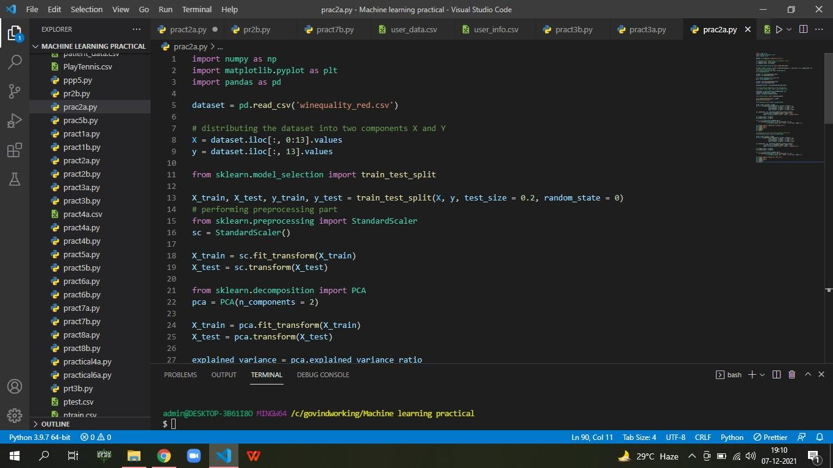

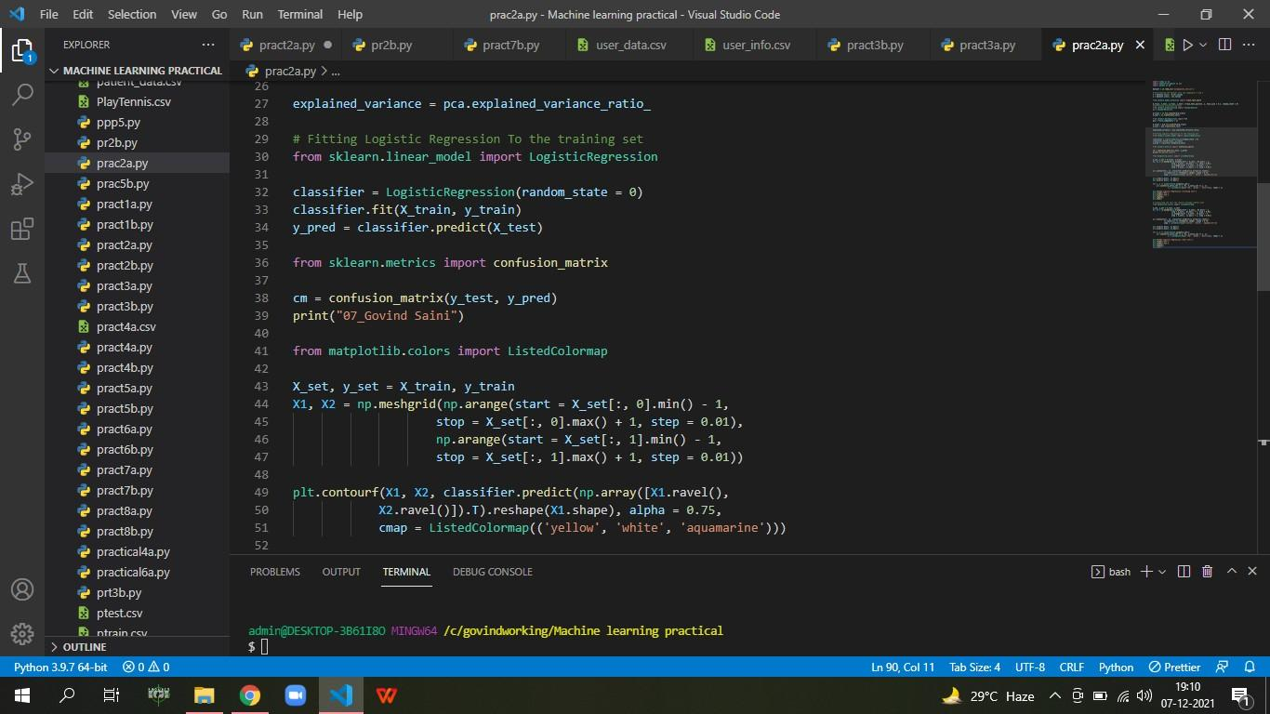

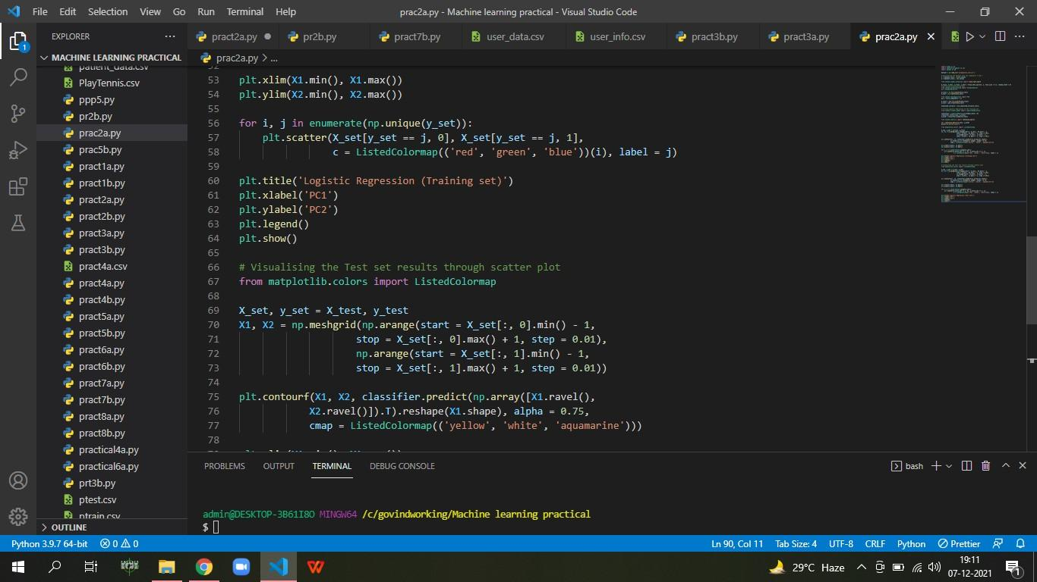

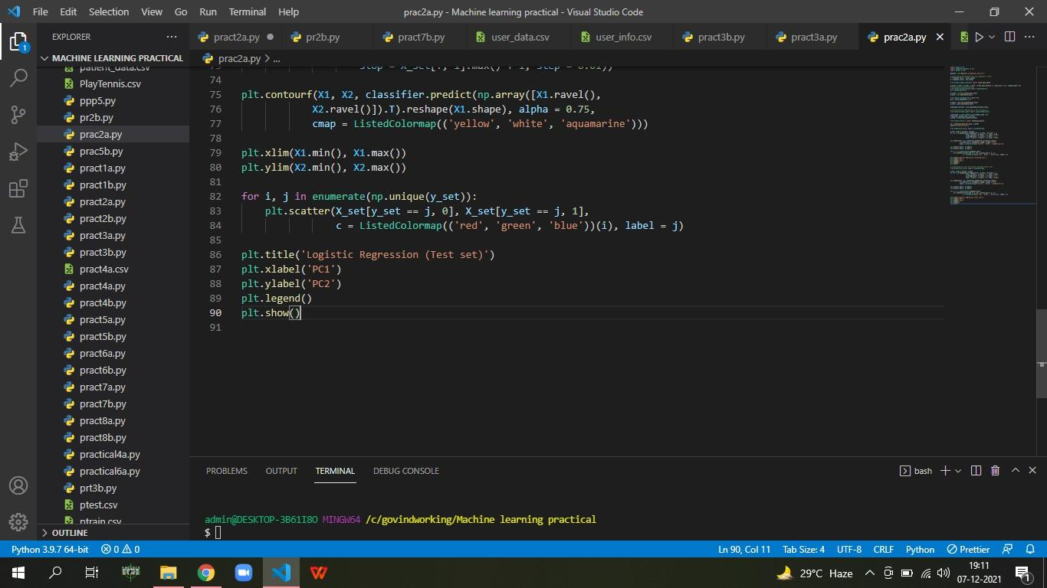

**OUTPUT:**

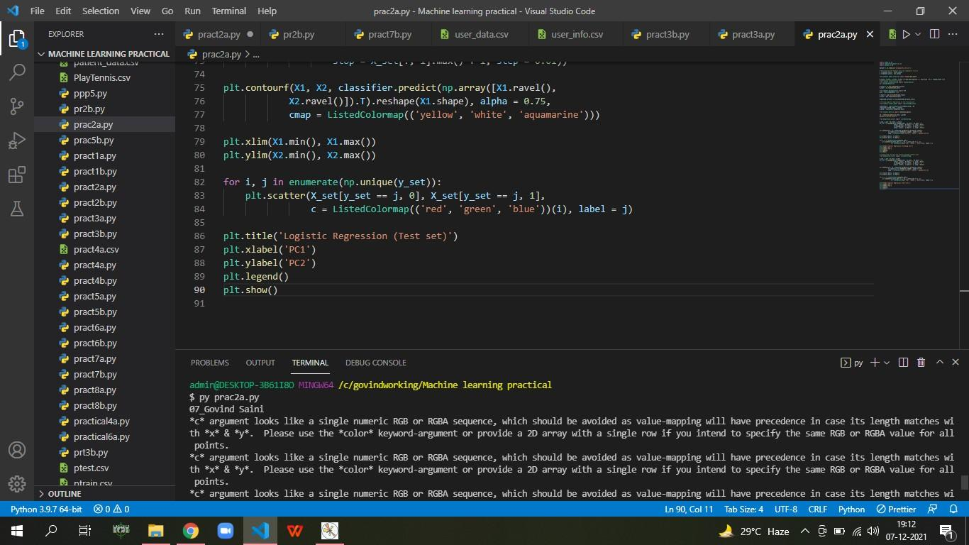

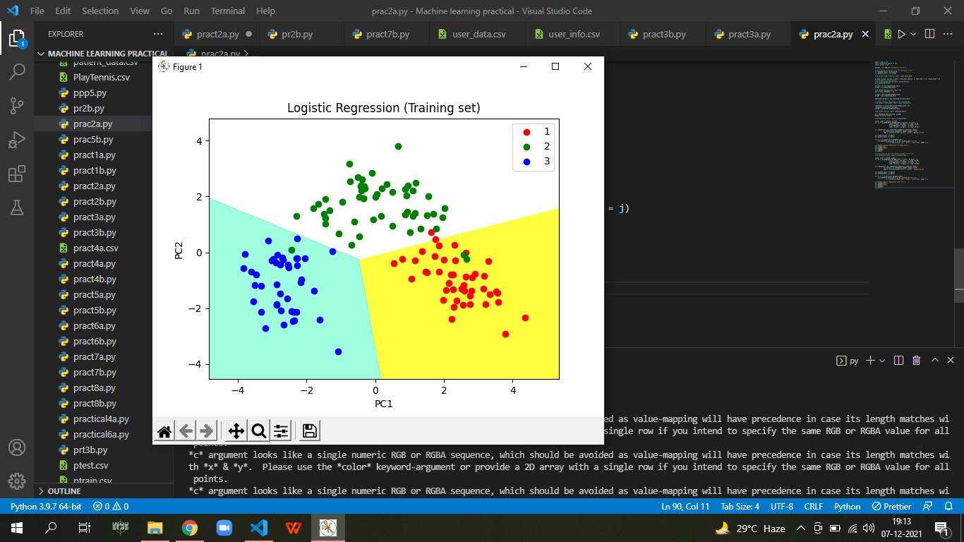

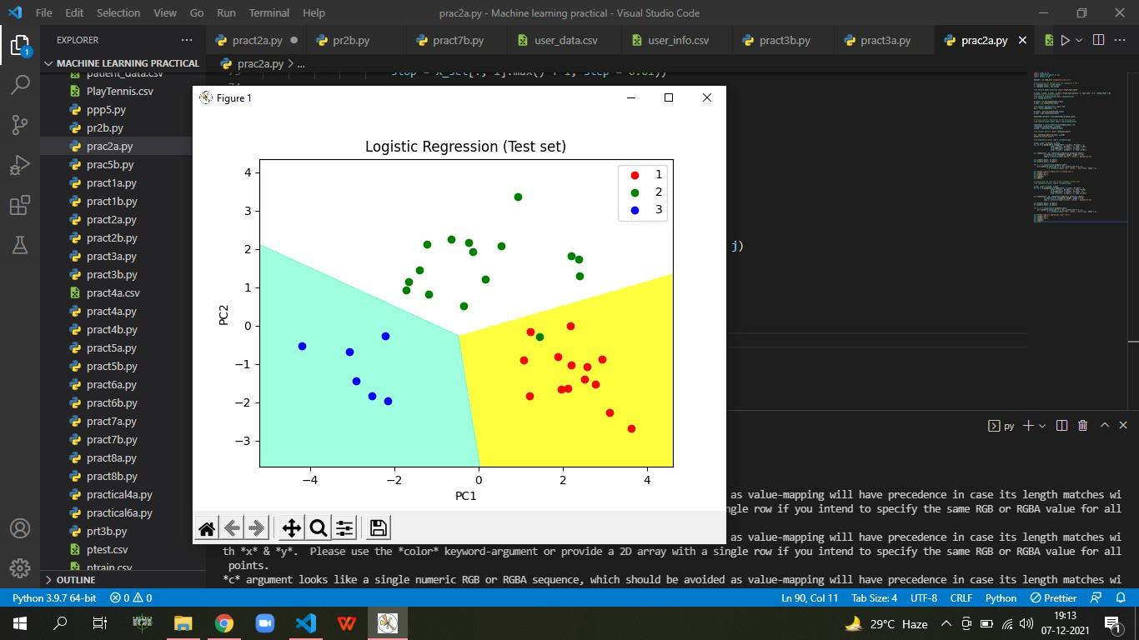

**B) For a given set of training data examples stored in.CSV file, implement and demonstrate the Candidate- Elimination algorithm to output a description of the set of all hypotheses consistent with the training examples**

**CODE:**

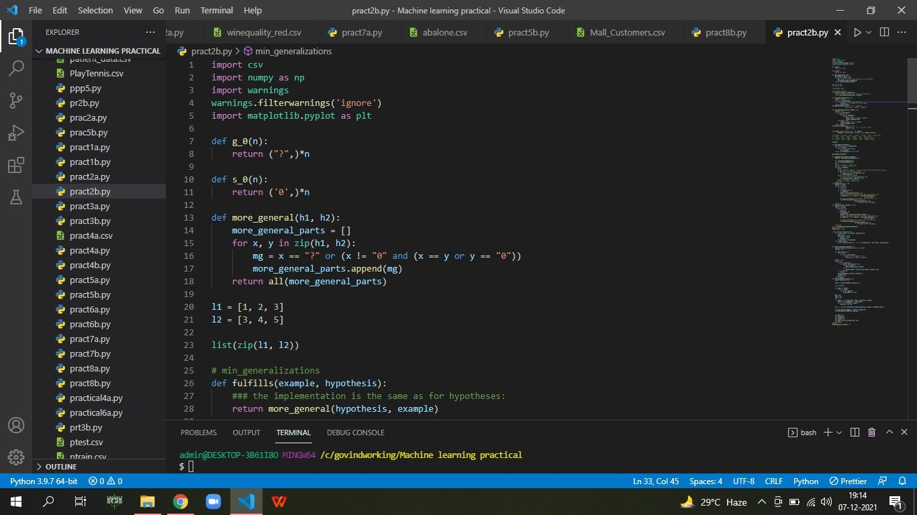

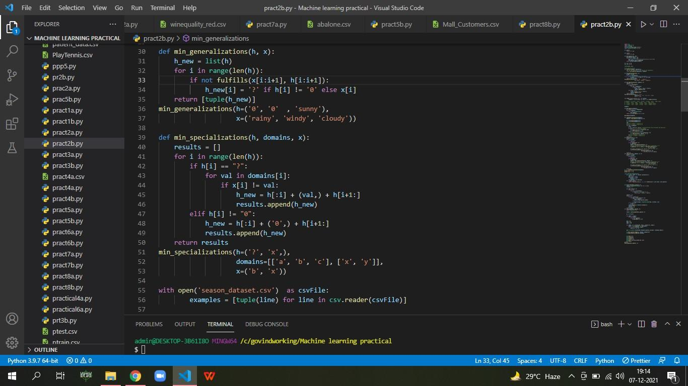

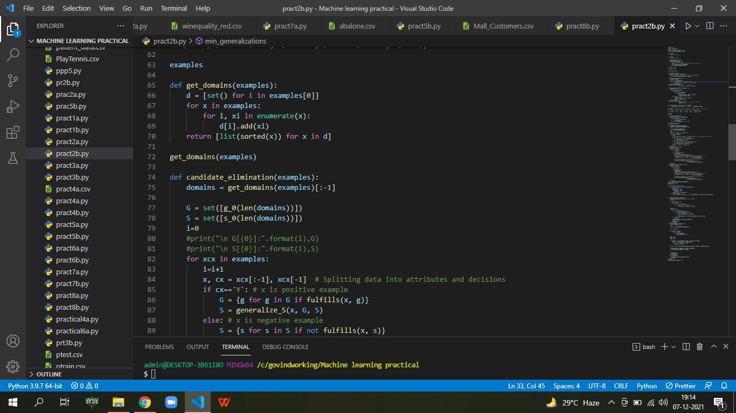

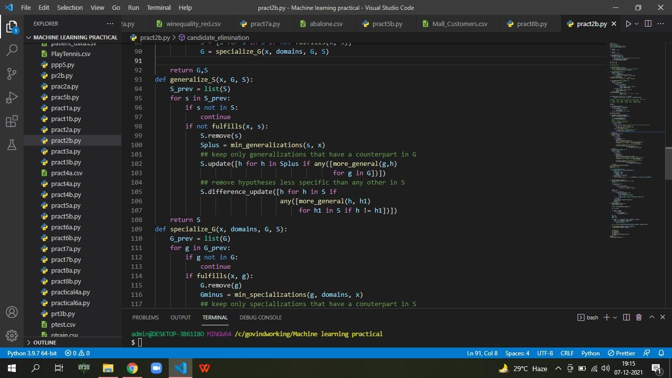

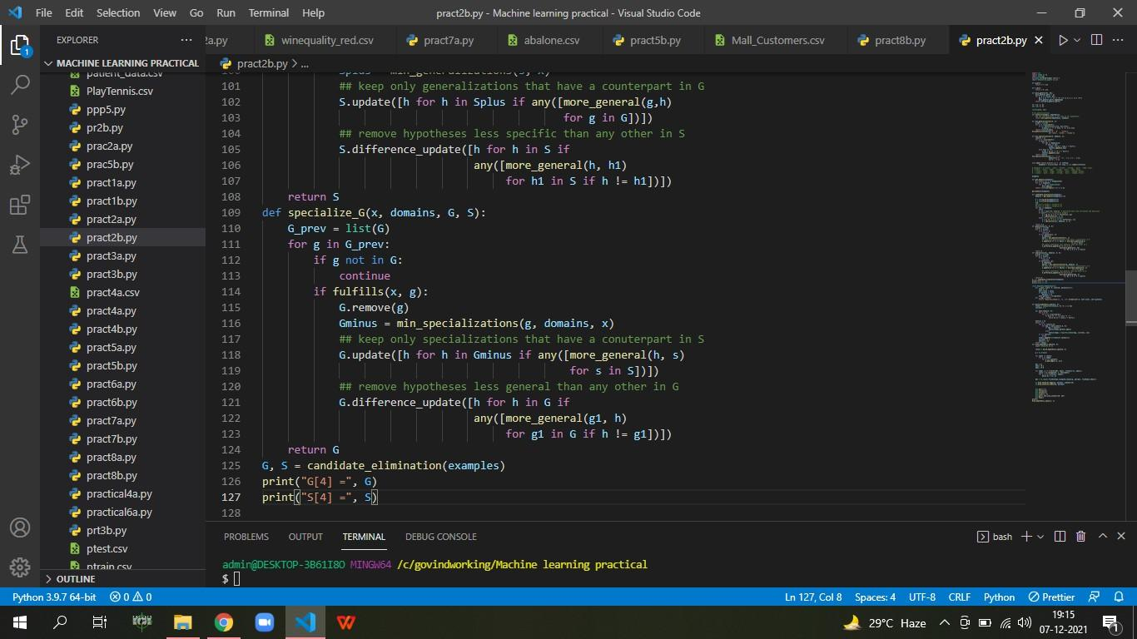

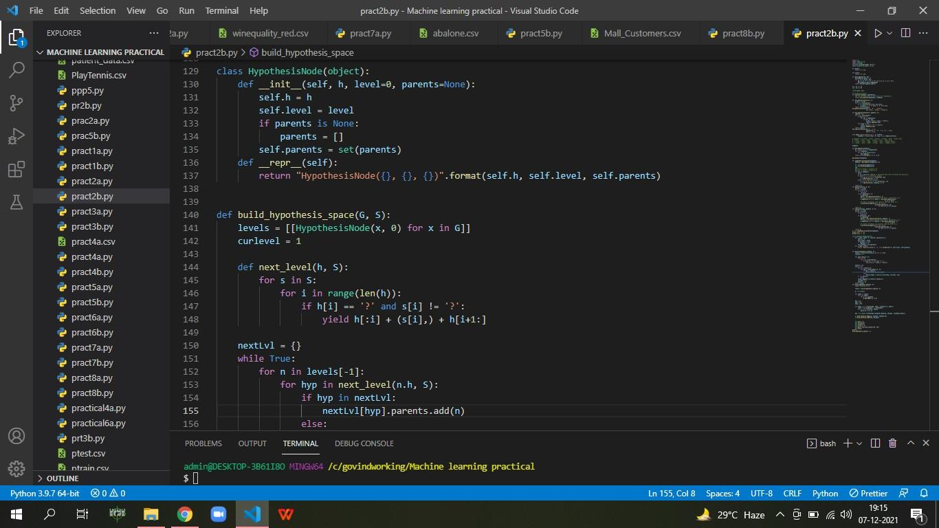

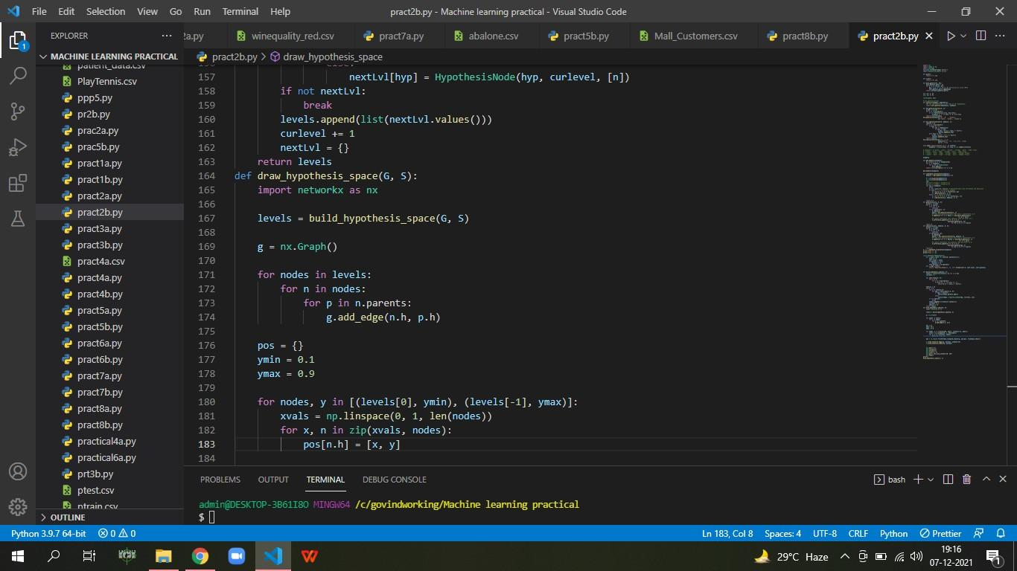

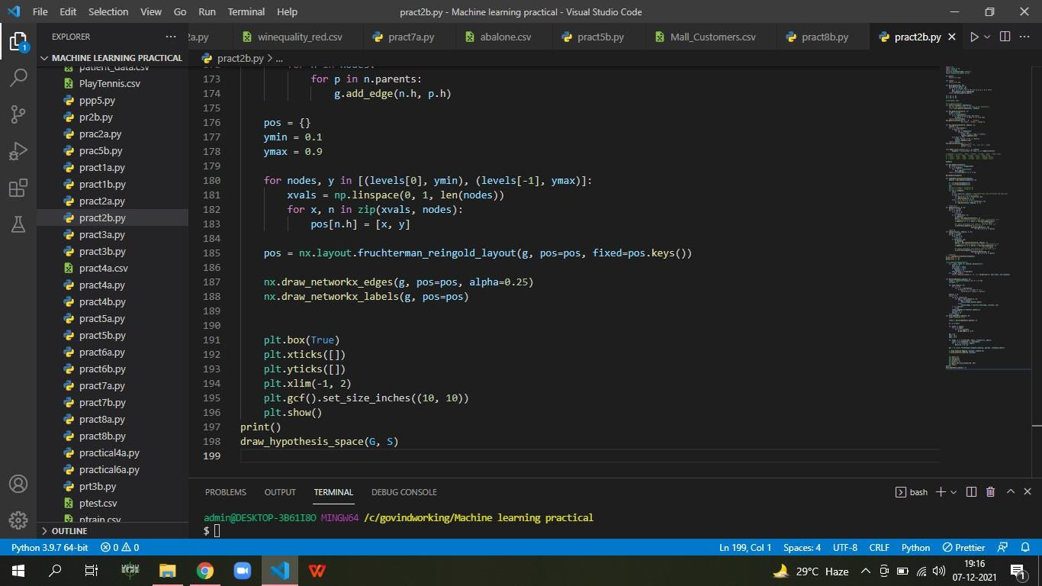

**OUTPUT:**

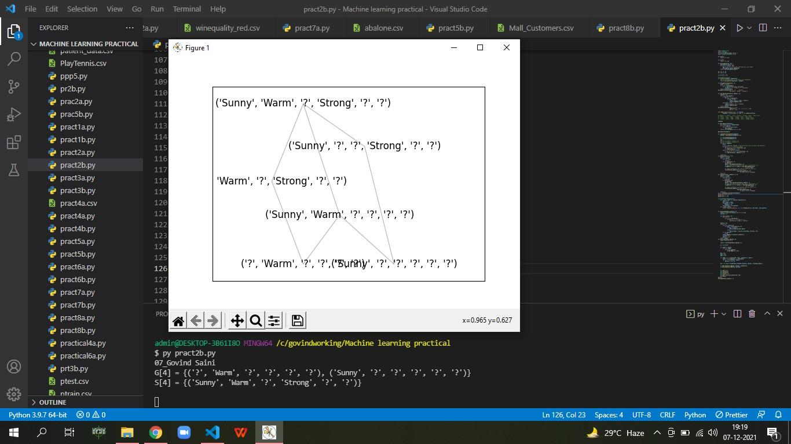

PRATICAL NO 3

**AIM: B) Write a program to implement Decision Tree and Random forest with Prediction, Test Score and Confusion Matrix.**

**CODE:**

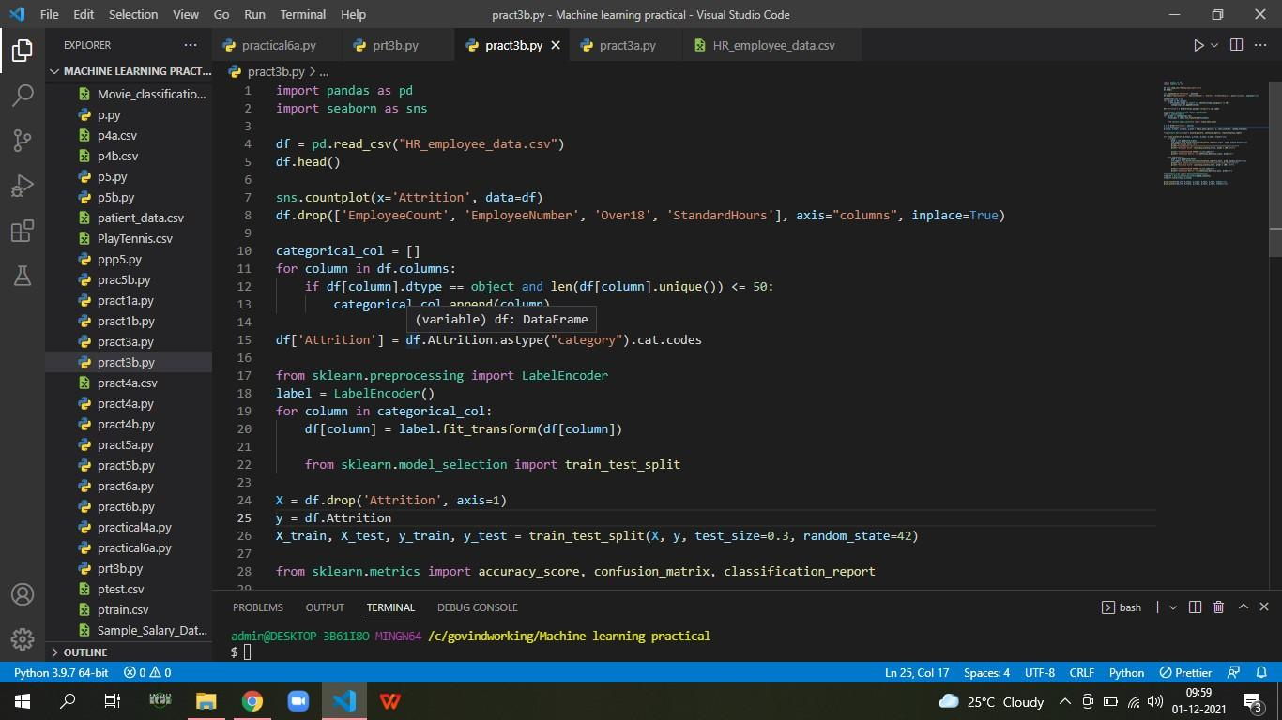

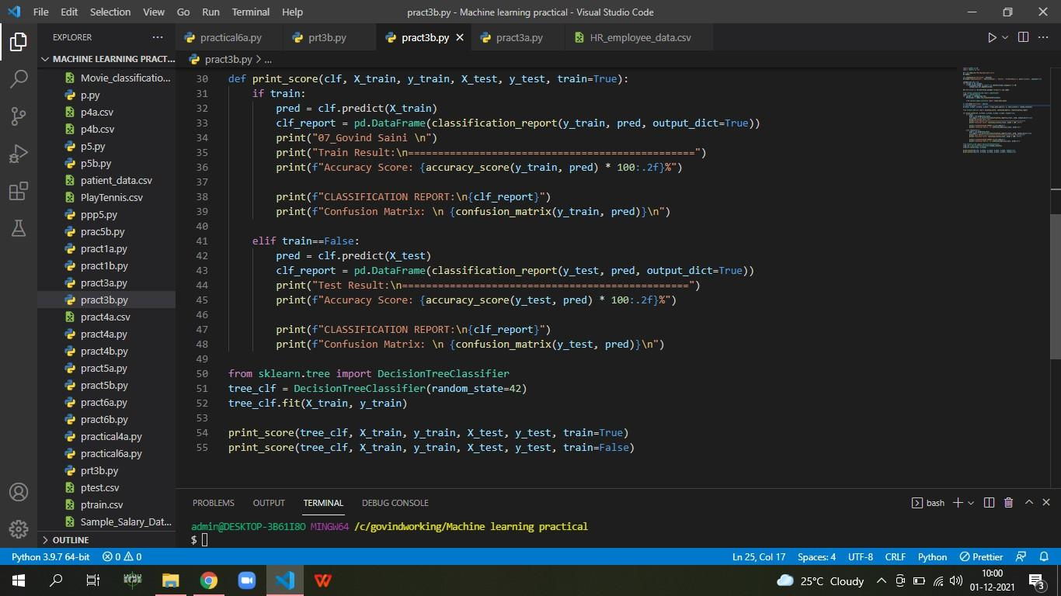

**OUTPUT:**

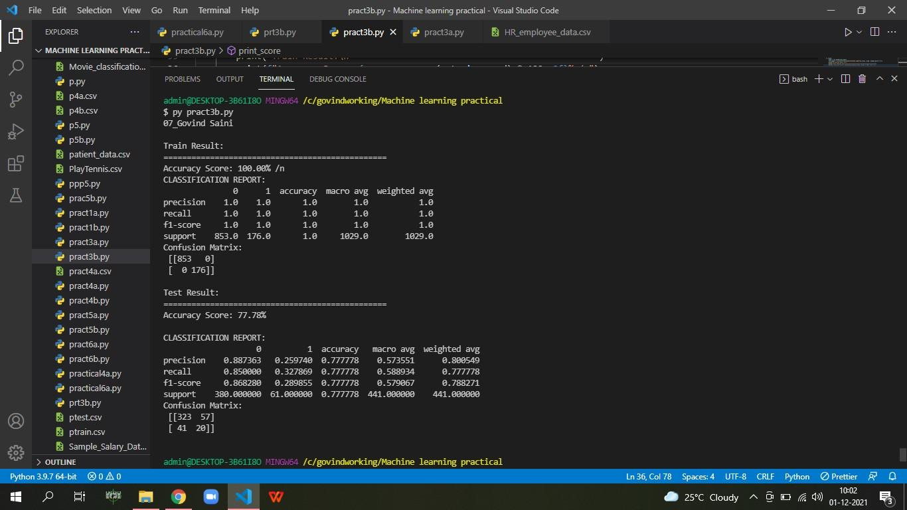

PRATICAL NO 4

**AIM: A) For a given set of training data examples stored in a .CSV file implement Least Square Regression algorithm. (Use Univariate dataset )**

**CODE:**

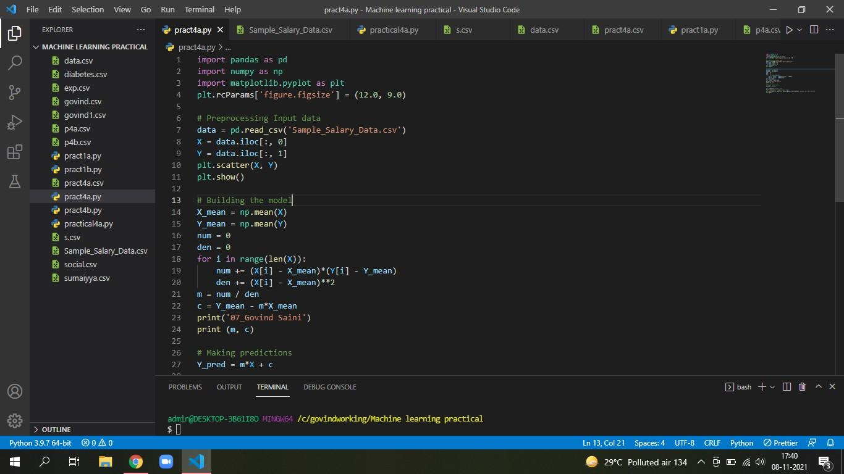

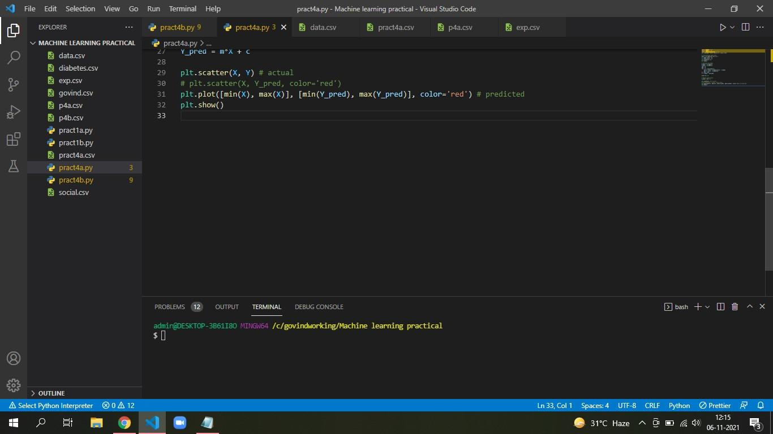

**OUTPUT:**

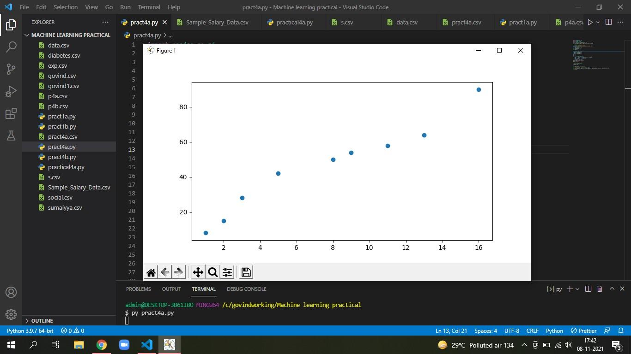

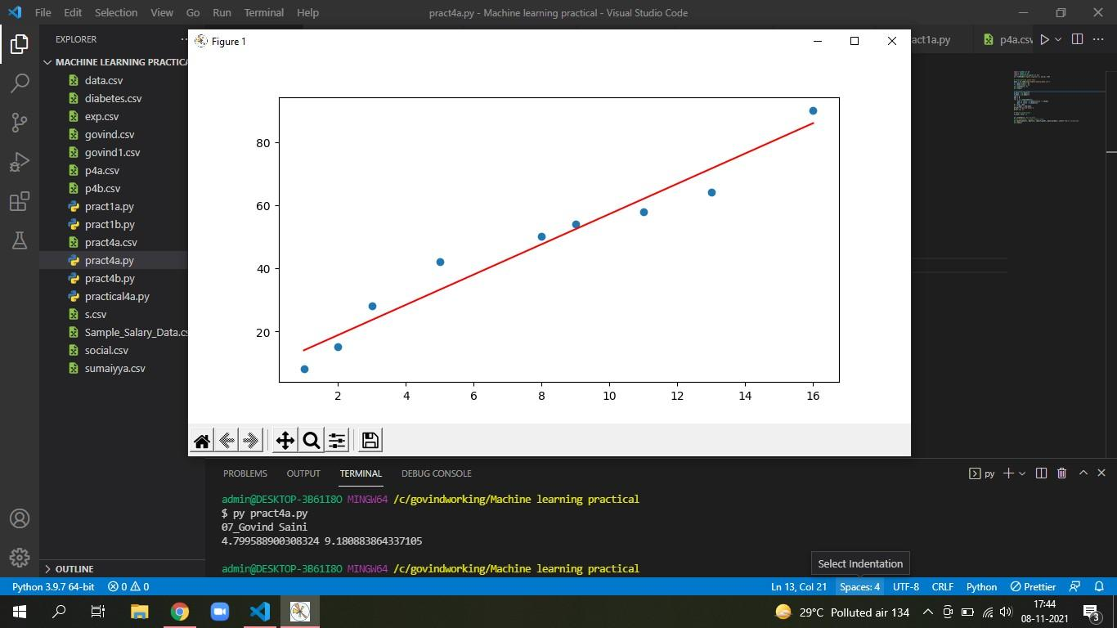

**AIM:B) For a given set of training data examples stored in a .CSV file implement Logistic Regression algorithm. (Use Multivariate dataset )**

**CODE:**

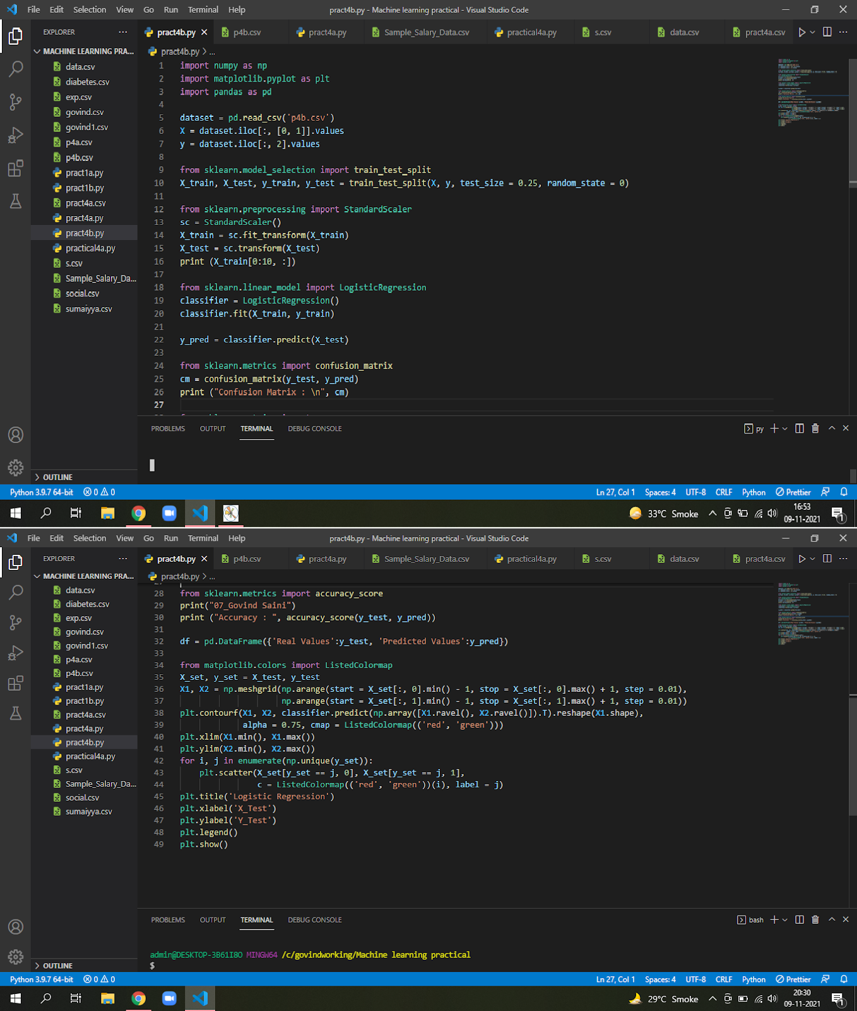

**OUTPUT:**

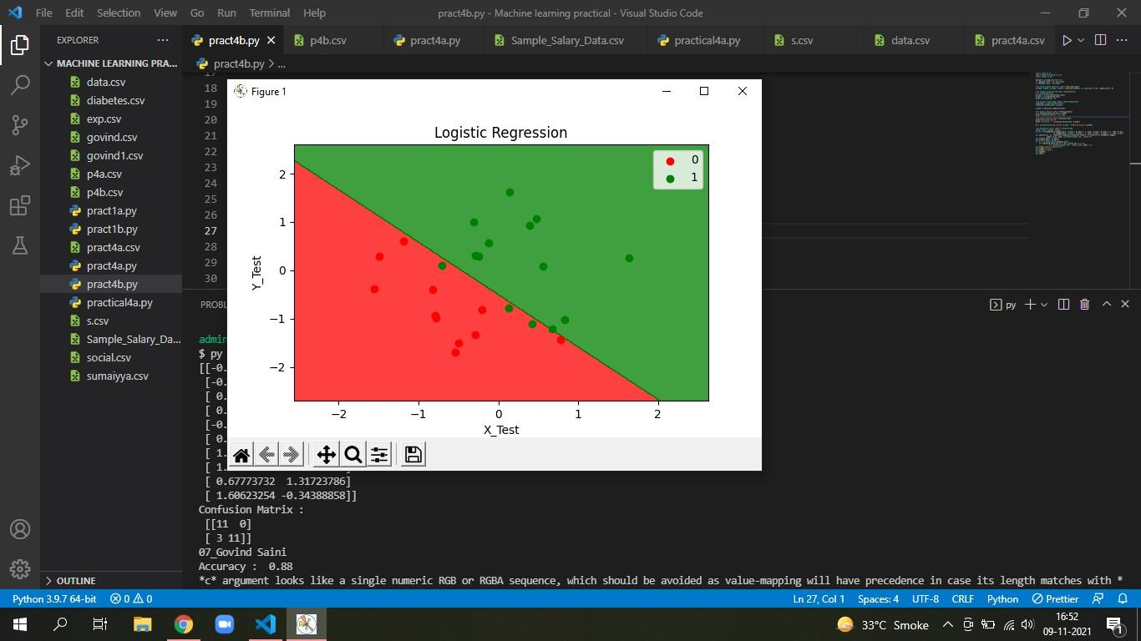

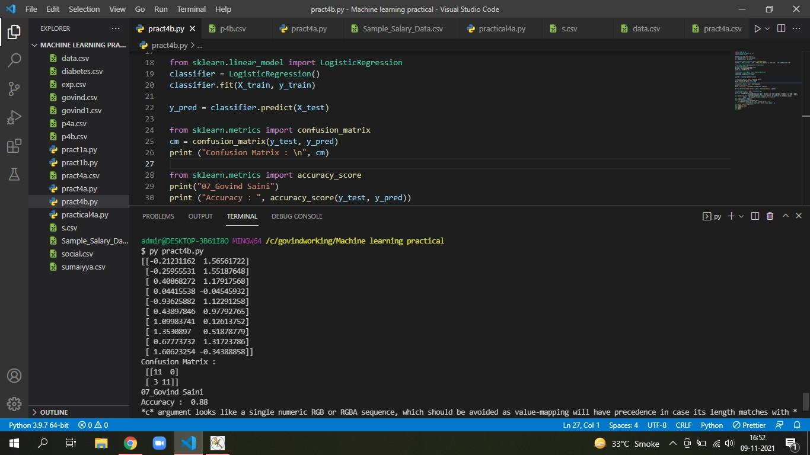

PRATICAL NO 5

**AIM: A) Write a program to demonstrate the working of the decision tree based ID3 algorithm. Use an appropriate data set for building the decision tree and apply this knowledge to classify a new sample.**

**CODE:**

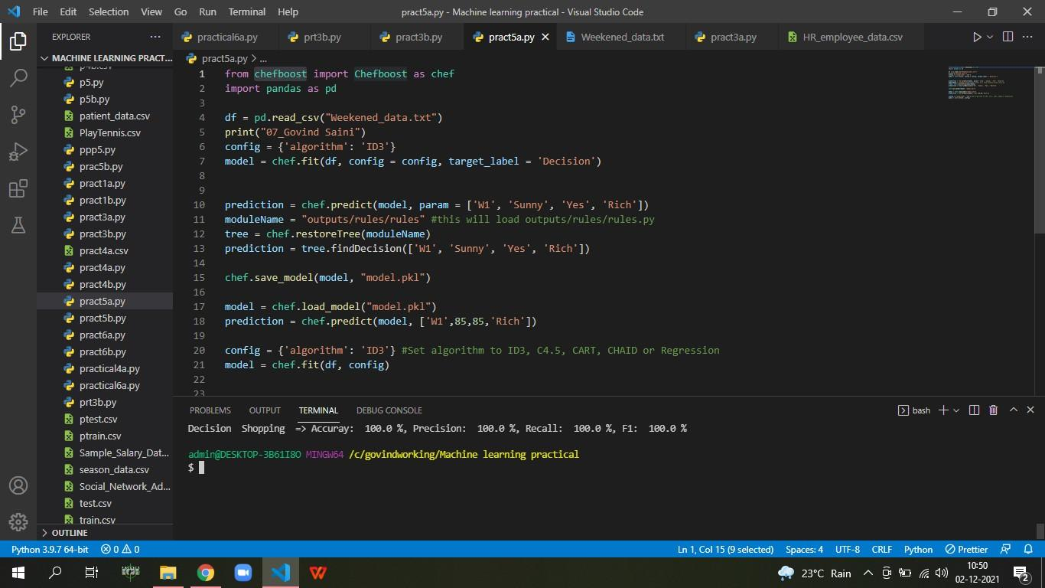

**OUTPUT:**

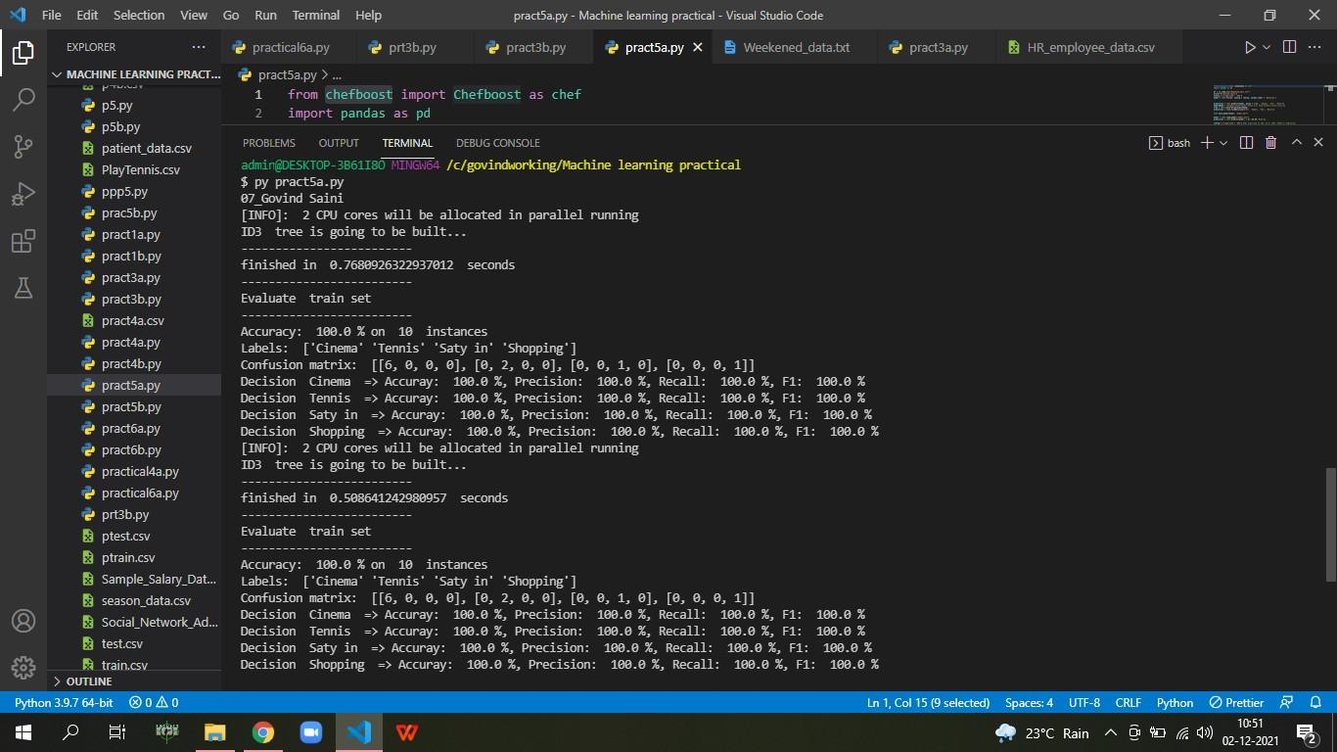

**AIM: B) Write a program to implement k-Nearest Neighbour algorithm to classify the iris data set.**

**CODE:**

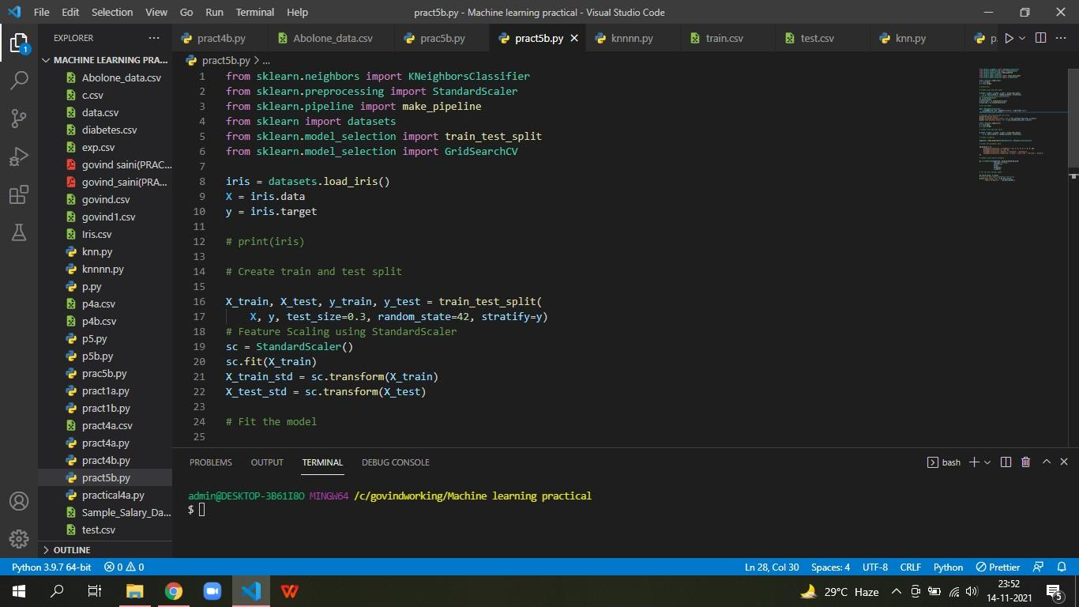

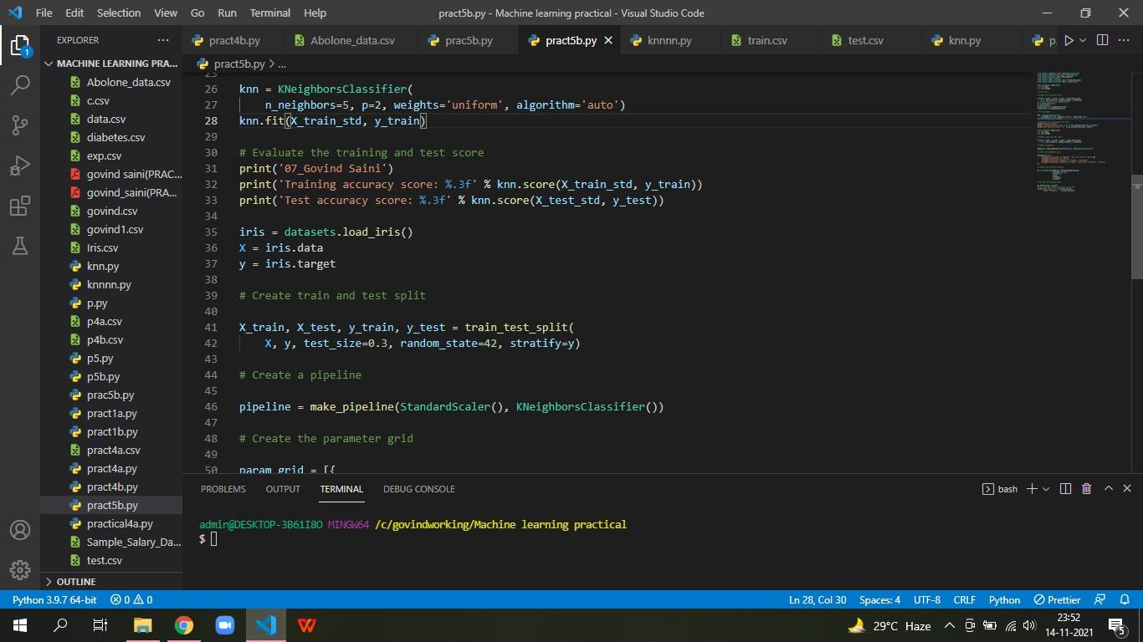

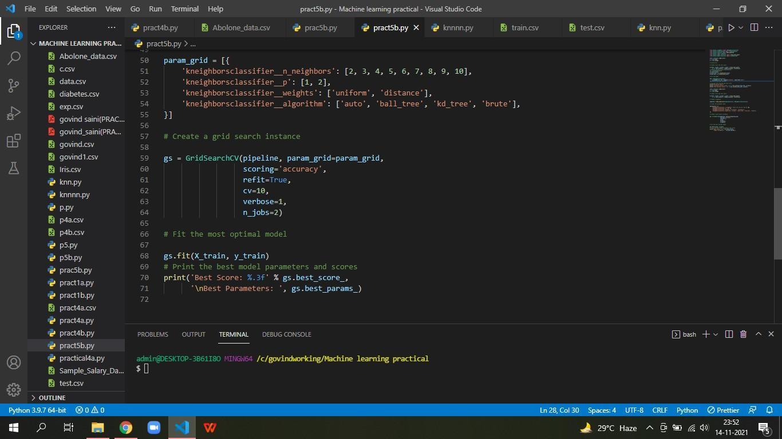

**OUTPUT:**

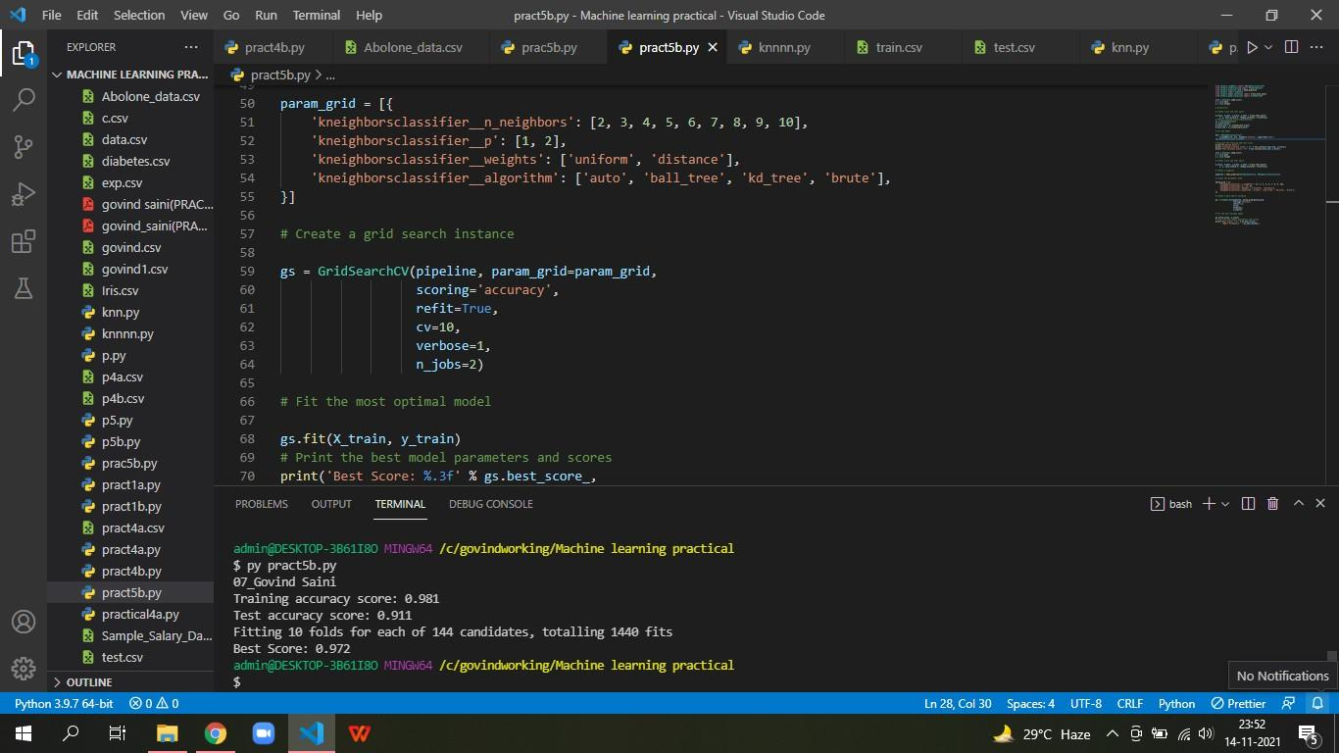

PRATICAL NO 6

**AIM: A) Implement the different Distance methods (Euclidean, Manhattan Distance, Minkowski Distance) with Prediction, Test Score and Confusion Matrix.**

**CODE:**

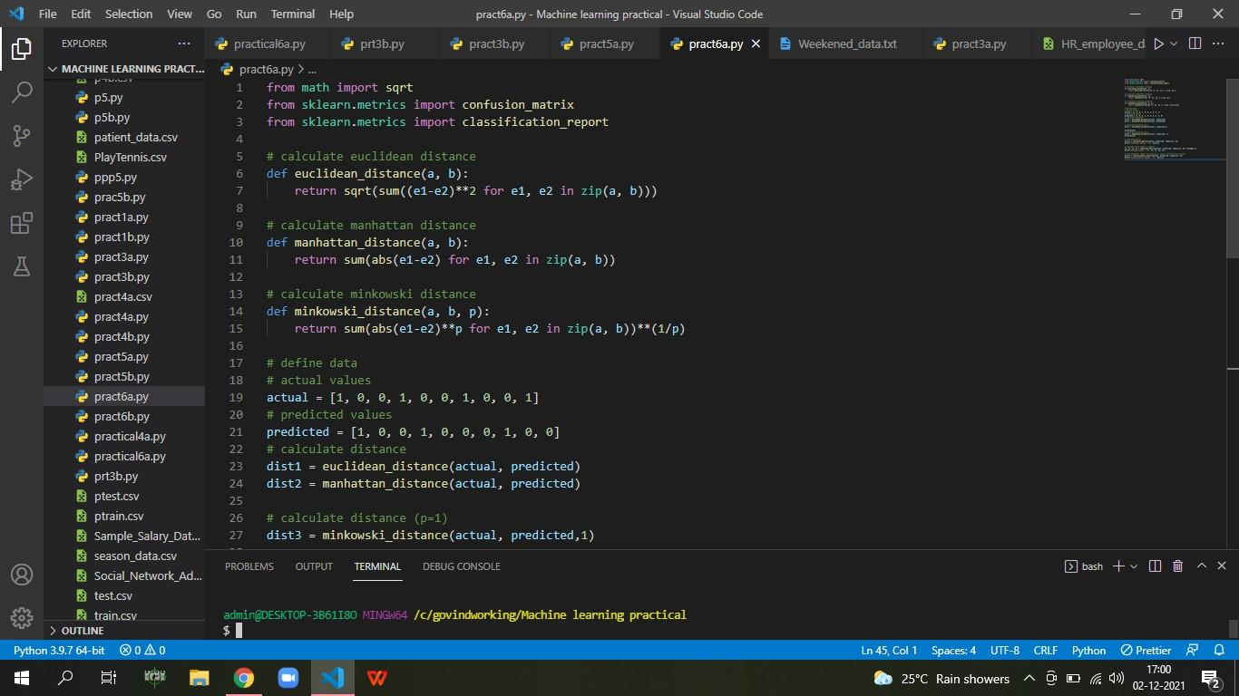

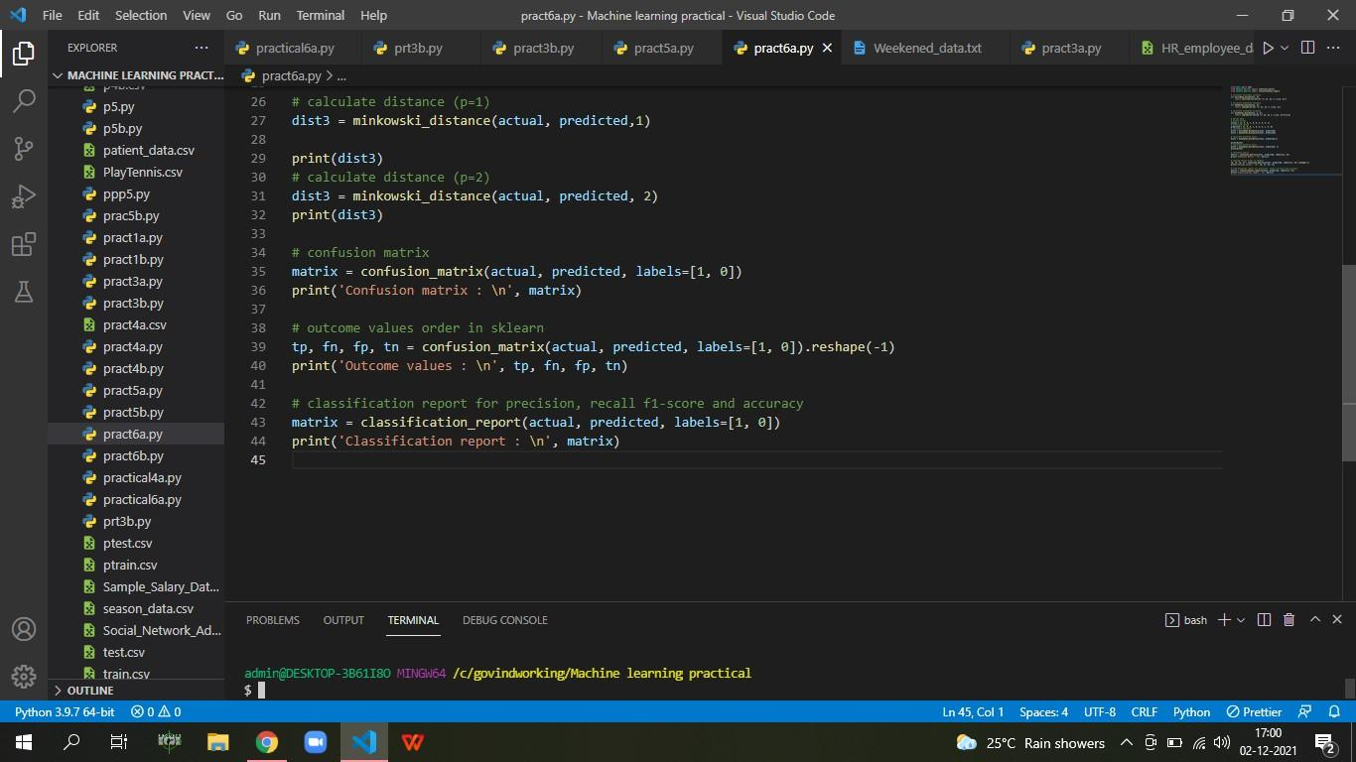

**OUTPUT:**

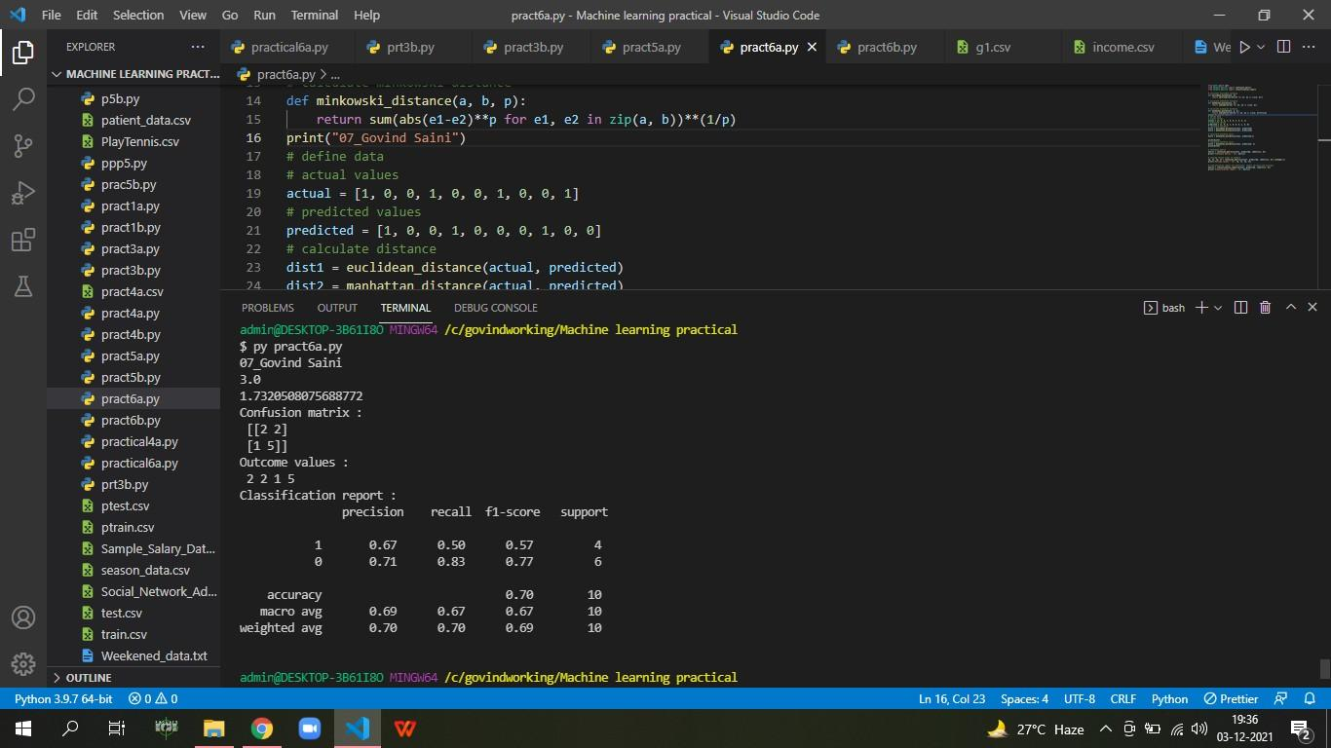

**AIM: B) Implement the classification model using clustering for the following techniques with K means clustering with Prediction, Test Score and Confusion Matrix.**

**CODE:**

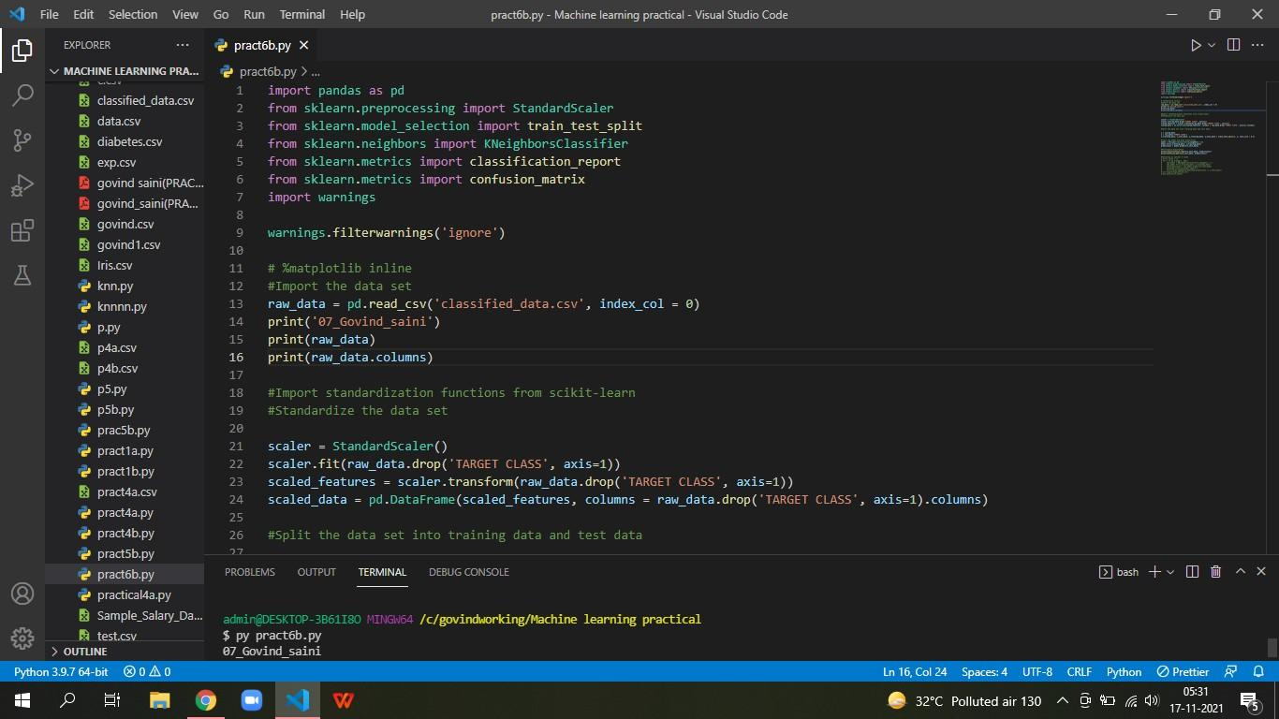

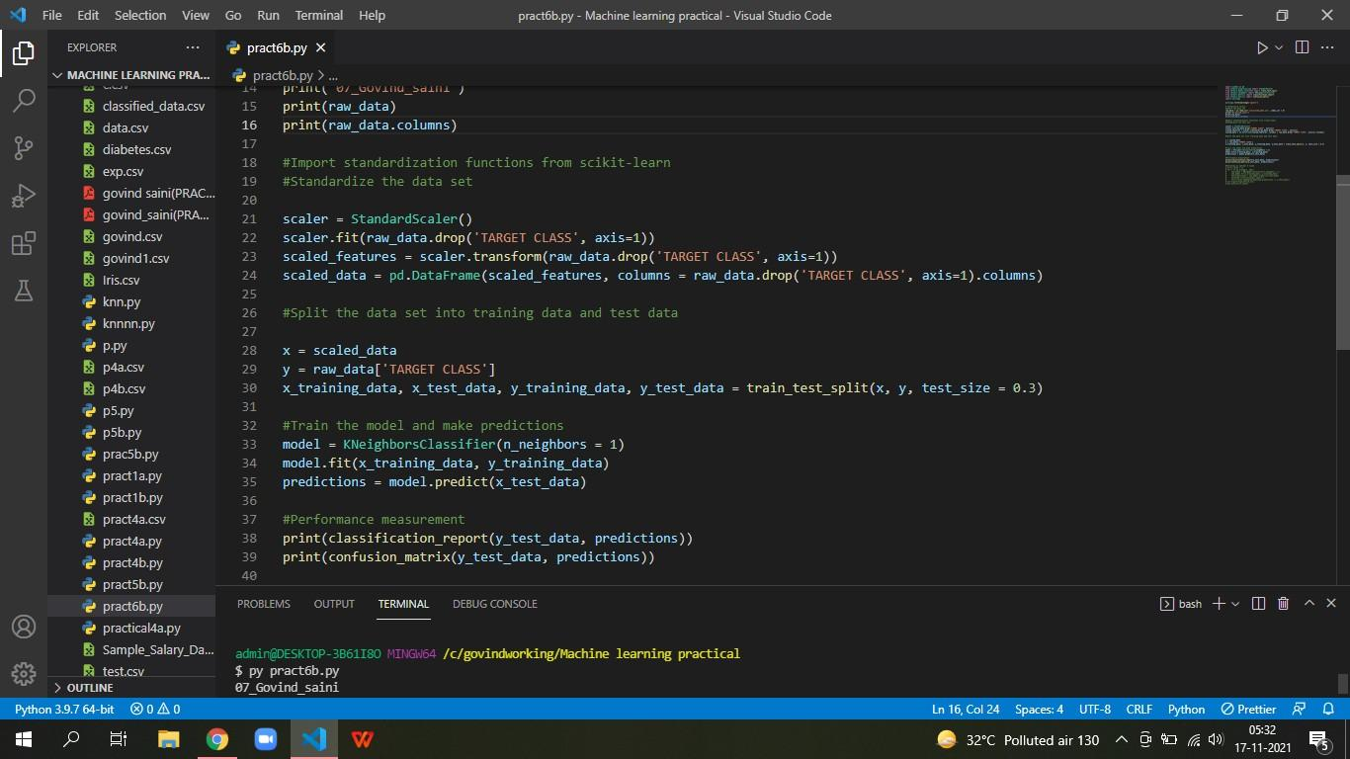

**OUTPUT:**

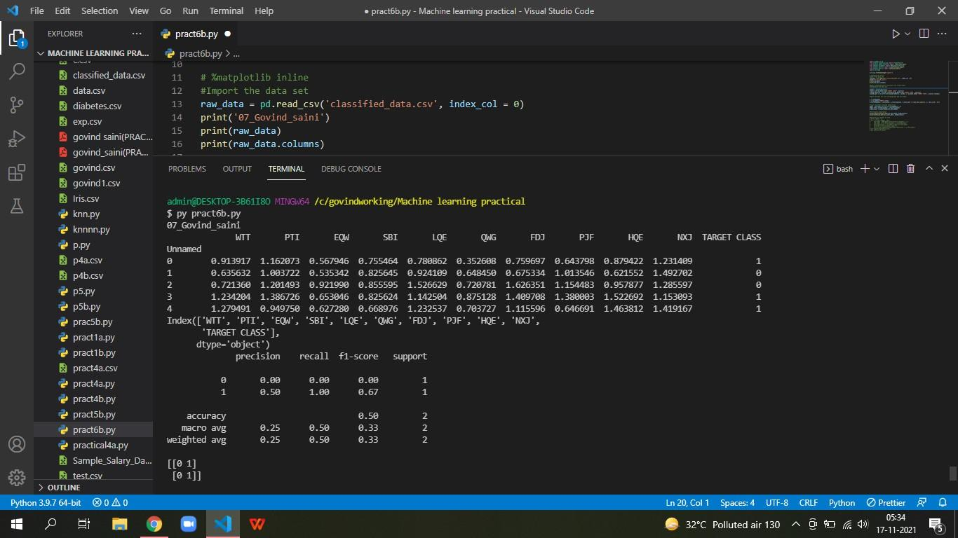

PRATICAL NO 7

**AIM:A) Implement the classification model using clustering for the following techniques with hierarchical clustering with Prediction, Test Score and Confusion Matrix**

**CODE:**

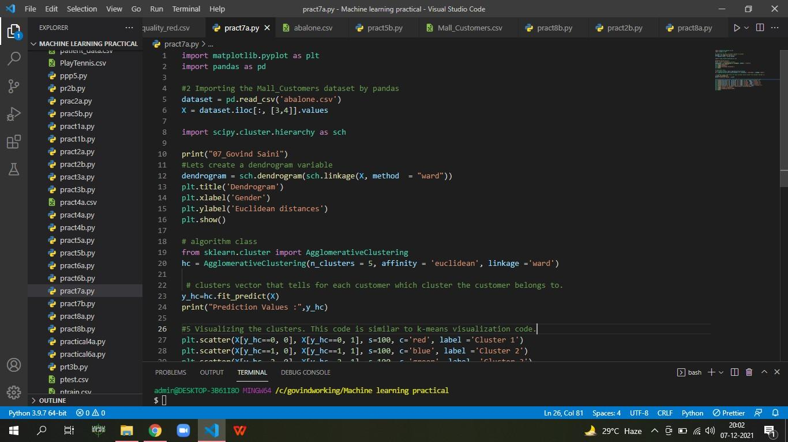

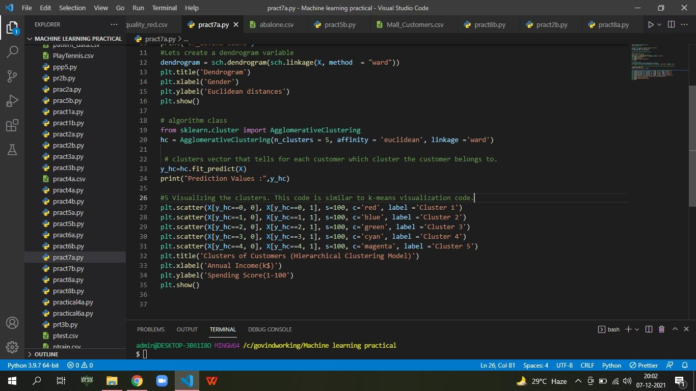

**OUTPUT:**

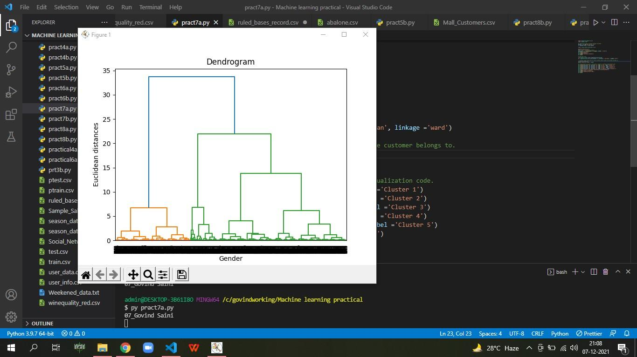

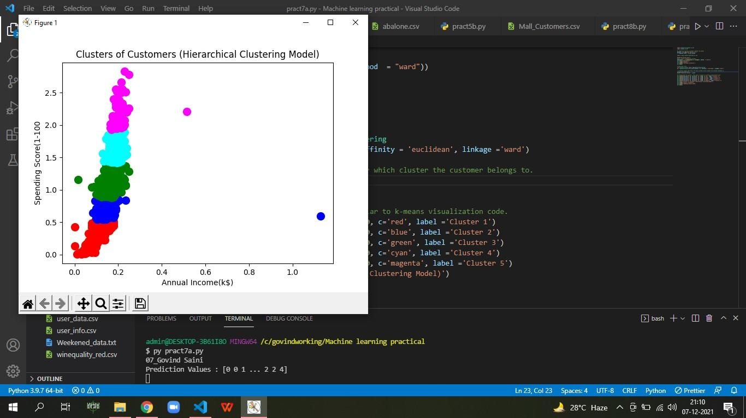

**AIM: B) Implement the Rule based method and test the same.**

**CODE:**

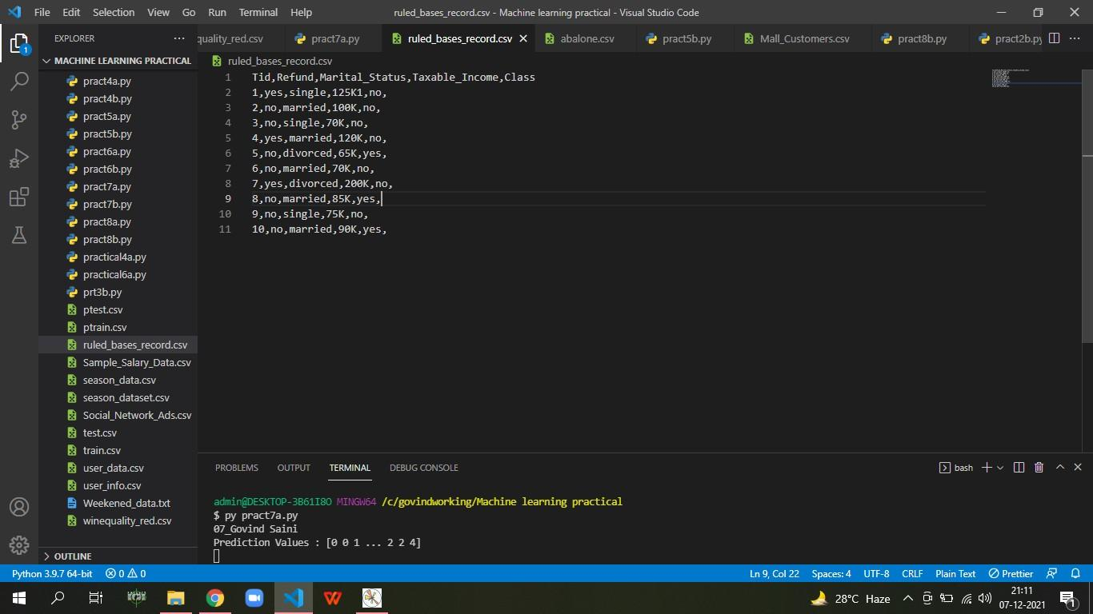

PRATICAL NO 8

**AIM: A) Write a program to construct a Bayesian network considering medical data. Use this model to demonstrate the diagnosis of heart patients using standard Heart Disease Data Set.**

**CODE:**

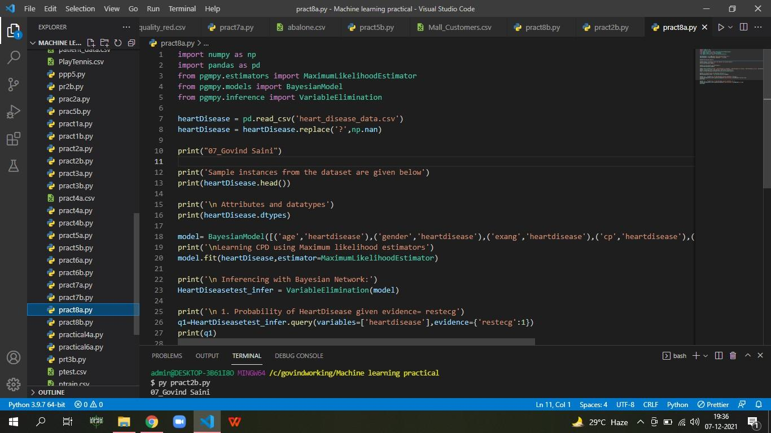

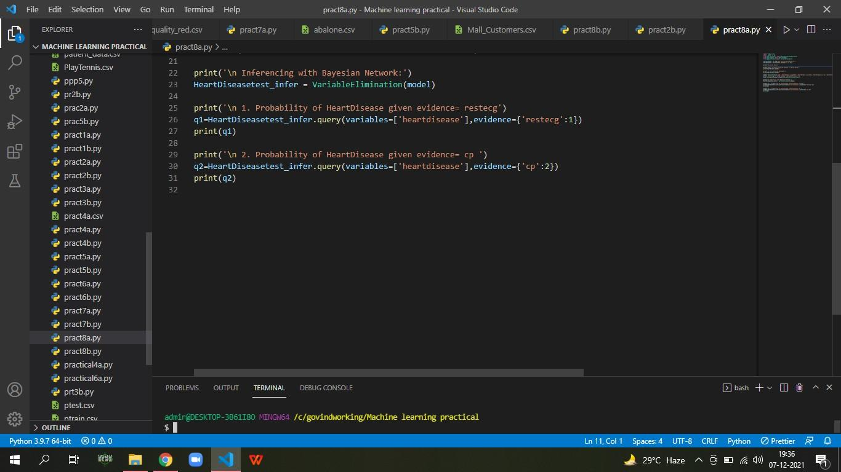

**OUTPUT:**

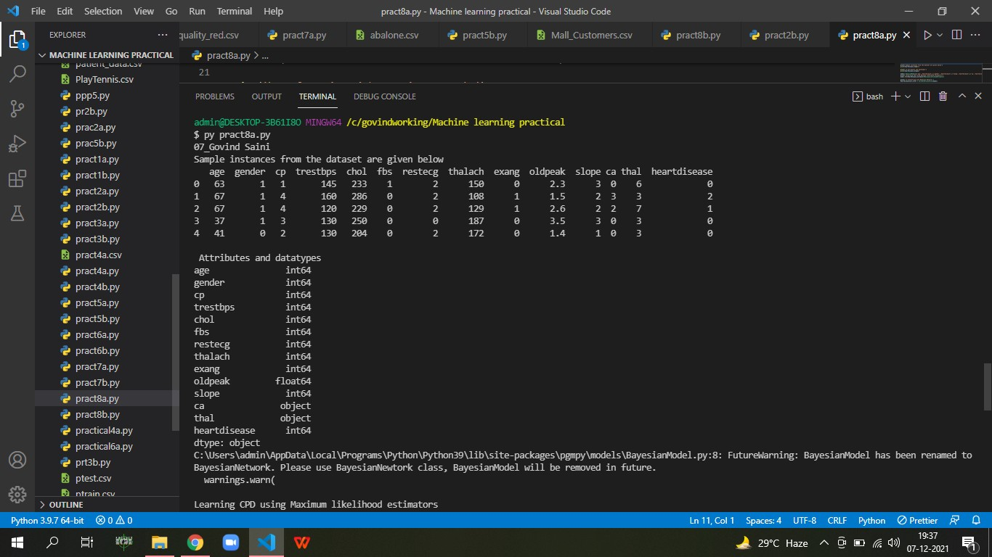

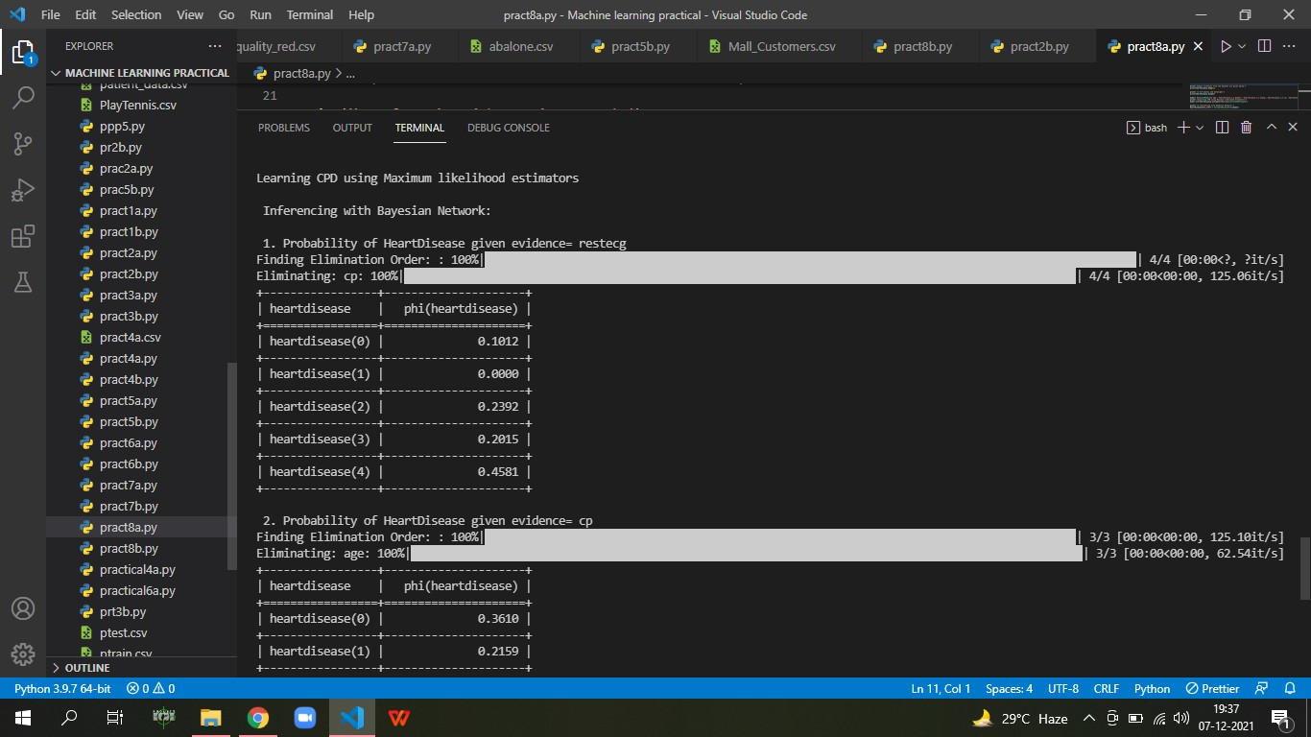

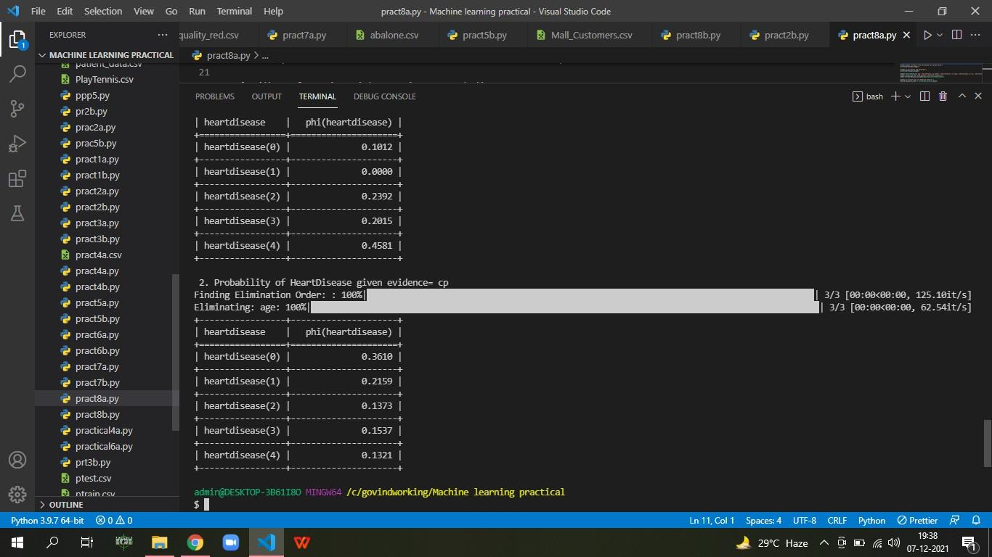

**AIM: B) Implement the non-parametric Locally Weighted Regression algorithm in order to fit data points. Select appropriate data set for your experiment and draw**

**graphs.**

**CODE:**

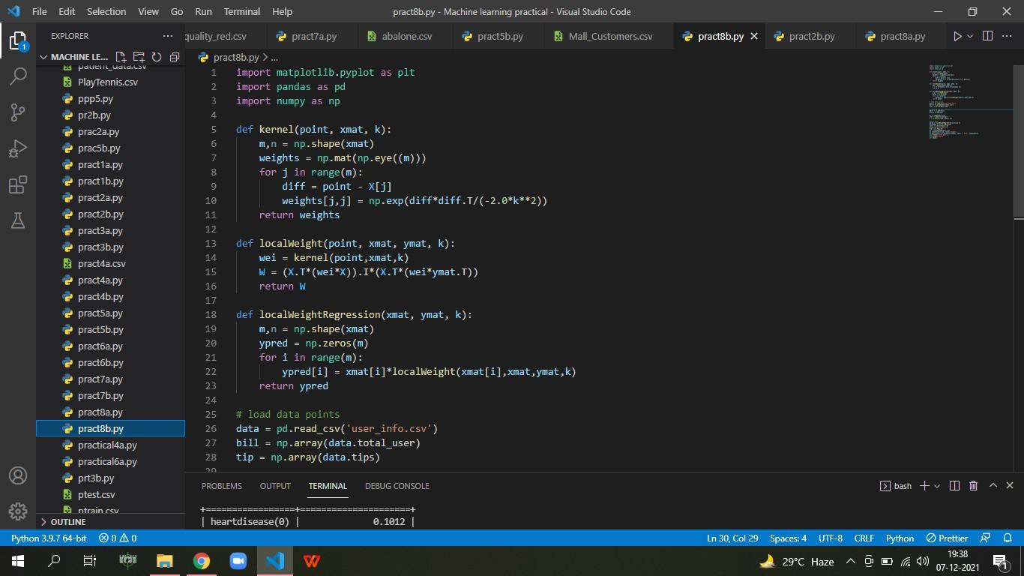

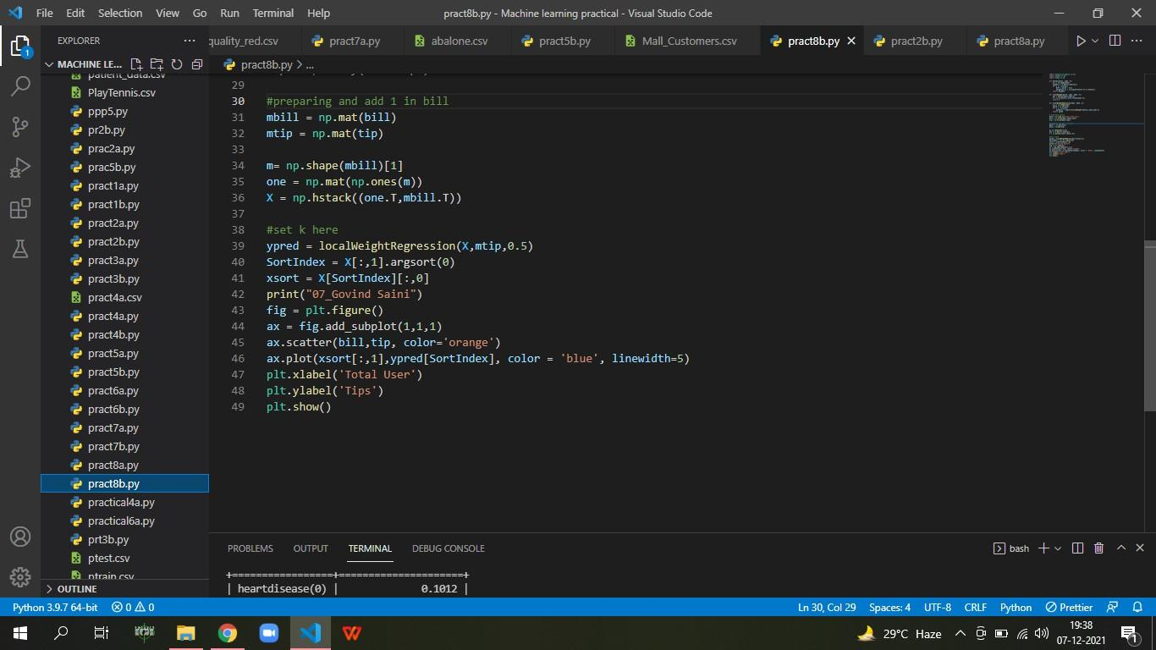

**OUTPUT:**

